* 1. **PROJECT PROFILE**

**Project Title :**  Library Management System

**Platform :** Microsoft Windows 10 Pro

**Back-end Used :**  Mysql 4.5.1

**Front-end Used :** PHP 7.0.9,Javascript

**Web Server** **:** Apache Server 2.4.23

**Team Size**  **:** 2

**Development Tools :** Notepad++,Pencil Software,Xampp

7.0.9

**Project Objective :**  Library management system consists of

Admin and users(Students and staffs ) to

perform basic operations of a library.

**Project Duration**  **:** 3 months

**Guided By** **:** Mr. John Calvin

**Submitted To**   **:**  Lowry Memorial College,Bangalore

**1.2 PROJECT INTRODUCTION**

Library management system is used to handle the entire activity of a library.The software keeps track of all information about the books in the library.The admin will find it easy to use an automated system rather than using the manual writing system which is tedious and time-consuming.The software is user-friendly and error-free.

It is used as an alternative means of record keeping of the books stored in the library.The administrator can view reports about the books available and users registered including students and staff.

It also provides user-friendly environment which allows user(Students and staff) to view books in the e-library for reference and search for books available.It is an error-free system which facilitates easy operation of the library and allows the librarian to add,delete,edit books and users(students and staff).

**2.1 HARDWARE AND SOFTWARE REQUIREMENTS**

**Client Side Tools:**

|  |  |
| --- | --- |
| **Processor** | PC with a Pentium III-class processor,600 Mhz processor. |
| **RAM** | 192 MB |
| **Hard Disk** | 45 MB of available space required on system drive of available or more. |
| **Operating System** | Windows 7,8,8.1,10,Windows Server 2003 Service Pack1 or later. |
| **Access** | MySql 4.5.1 |
| **Browser** | Google Chrome,Opera |

**Server Side Tools:**

|  |  |
| --- | --- |
| **Processor** | PC with a Pentium III-class processor,600 Mhz processor. |
| **RAM** | 512 MB |
| **Hard Disk** | 80GB |
| **Operating System** | Windows 7,8,8.1,10,Windows Server 2003 Service Pack1 or later. |
| **Software** | Mysql,PHP,Apache Server |
| **Browser** | Google Chrome,Opera |

**Development Side Tools:**

|  |  |
| --- | --- |
| **Processor** | PC with Intel Core |
| **RAM** | 1 GB |
| **Hard Disk** | 320 GB |
| **Operating System** | Windows 7,8,8.1,10,Windows Server 2003 Service Pack1 or later. |
| **Software** | XAMPP Server,Notepad++,Pencil |
| **Browser** | Google Chrome,Opera |

**2.2 TECHNOLOGY USED**

**What is PHP?**

* PHP is a recursive acronym for "PHP: Hypertext Preprocessor".
* PHP is a server side scripting language that is embedded in HTML. It is used to manage dynamic content, databases, session tracking, even build entire ecommerce sites.
* PHP is a recursive acronym for "PHP: Hypertext Preprocessor".
* PHP is a server side scripting language that is embedded in HTML. It is used to manage dynamic content, databases, session tracking, even build entire ecommerce sites.

It is integrated with a number of popular databases, including MySQL, PostgreSQL.

COMMON USES OF PHP:

* Oracle, Sybase, Informix, and Microsoft SQL Server.
* PHP is pleasingly zippy in its execution, especially when compiled as an Apache module on the Unix side. The MySQL server, once started, executes even very complex queries with huge result sets in record-setting time.
* PHP supports a large number of major protocols such as POP3, IMAP, and LDAP. PHP4 added support for Java and distributed object arch It is integrated with a number of popular databases, including MySQL, PostgreSQL, Oracle, Sybase, Informix, and Microsoft SQL Server.
* PHP is pleasingly zippy in its execution, especially when compiled as an Apache module on the Unix side. The MySQL server, once started, executes even very complex queries with huge result sets in record-setting time.
* PHP can handle forms, i.e. gather data from files, save data to a file, thru email you can send data, return data to the user.
* You add, delete, modify elements within your database thru PHP.
* Access cookies variables and set cookies.
* Using PHP, you can restrict users to access some pages of your website.
* It can encrypt data.

**What can PHP do?**

Anything. PHP is mainly focused on server-side scripting, so you can do anything any other CGI program can do, such as collect form data, generate dynamic page content, or send and receive cookies. But PHP can do much more.

There are three main areas where PHP scripts are used.

**Server-side scripting:**This is the most traditional and main target field for PHP. You need three things to make this work: the PHP parser (CGI or server module), a web server and a web browser. You need to run the web server, with a connected PHP installation. You can access the PHP program output with a web browser, viewing the PHP page through the server. All these can run on your home machine if you are just experimenting with PHP programming. See the installation instructions section for more information.

**Command line scripting:**You can make a PHP script to run it without any server or browser. You only need the PHP parser to use it this way. This type of usage is ideal for scripts regularly executed using cron (on *nix or Linux) or Task Scheduler (on Windows). These scripts can also be used for simple text processing tasks. See the section about Command line usage of PHP for more information.

**Writing desktop applications**: PHP is probably not the very best language to create a desktop application with a graphical user interface, but if you know PHP very well, and would like to use some advanced PHP features in your client-side applications you can also use PHP-GTK to write such programs. You also have the ability to write cross-platform applications this way. PHP-GTK is an extension to PHP, not available in the main distribution.

**MYSQL:**

* **Relational Database Management System (RDBMS):** MySQL is a relational database management system.
* **Easy to use:**MySQL is easy to use. You have to get only the basic knowledge of SQL. You can build and interact with MySQL with only a few simple SQL statements.
* **It is secure:**MySQL consist of a solid data security layer that protects sensitive data from intruders. Passwords are encrypted in MySQL.
* **Client/ Server Architecture**: MySQL follows a client /server architecture. There is a database server (MySQL) and arbitrarily many clients (application programs), which communicate with the server; that is, they query data, save changes, etc.
* **Free to download:** MySQL is free to use and you can download it from MySQL official website.
* **It is scalable:** MySQL can handle almost any amount of data, up to as much as 50 million rows or more. The default file size limit is about 4 GB. However, you can increase this number to a theoretical limit of 8 TB of data.
* **Compatibale on many operating systems**: MySQL is compatible to run on many operating systems, like Novell NetWare, Windows* Linux*, many varieties of UNIX* (such as Sun* Solaris*, AIX, and DEC* UNIX), OS/2, FreeBSD*, and others. MySQL also provides a facility that the clients can run on the same computer as the server or on another computer (communication via a local network or the Internet).
* **Allows roll-back:** MySQL allows transactions to be rolled back, commit and crash recovery.
* **High Performance:** MySQL is faster, more reliable and cheaper because of its unique storage engine architecture.
* **High Flexibility:** MySQL supports a large number of embedded applications which makes MySQL very flexible.

**APACHE SERVER:**

Apache is developed and maintained by an open community of developers under the auspices of the Apache Software foundation.

**Features of Apache Server:**

* Apache supports a variety of features, many implemented as compiled modules which extend the core functionality.These can range from server-side programming language support to authentication schemes.
* Some common language interfaces support Perl,Python,Tcl and PHP.Popular authentication modules include mod_access,mod_auth,mod_digest,and mod_auth_digest,the successor to mod_digest.
* A sample of other features include SSL and TLS support(mod_ssl),a proxy module(mod_proxy),a URL rewriter(also known as a rewrite engine, implemented under mod_rewrite).
* Virtual hosting allows one Apache installation to serve many different actual systems.
* Apache features configurable error messages,DBMS-based authentication databases,and content negotiation.It is also supported by several graphical user interfaces(GUIs).

**PERFORMANCE OF APACHE SERVER:**

* Although the main design goal of Apache is not to be the “fastest” web server.Apache does have performance comparable to other “high-performance” web servers.
* Instead of implementing a single architecture,Apache provides a variety of Multiproccessing Modules(MPM’s) which allow Apache to run in a process-based,hybrid(process and thread) or event-hybrid mode,to better match the demands of each particular

infrastructure.

* The Apache version considered by the Apache Foundation as providing high-performance is the multi-threaded version which mixes the use of several processes and several threads per process.

**3.1 INTRODUCTION OF EXISTING SYSTEM**

In “Library Management System” some work can be done manually but some cannot because it is time consuming and cumbersome to do that work.

Before developing this project all the problems were identified thoroughly and we performed the analysis on existing system.

Before developing “Library Management System”,the existing library is completely done manually.

**Student Record:**

All the information of students are maintained by paper work,which is very difficult and time consuming to maintain and search.

**Staff record:**

All the information of staff is maintained on paper which is not secure.

**Books records:**

The information about books are maintained on paper which is very difficult and time consuming to maintain and search.

**3.2 SCOPE OF SYSTEM**

The **“LIBRARY MANAGEMENT SYSTEM”** is concerned with two categories of modules

1. Admin Modules
2. User Modules (Student And Staff)

**Admin Module:**

1. **Add Book:**Admin can add new book details.
2. **Manage Book:**Admin can update as well as delete the book details.
3. **Add Category:**Admin can add new categories of books.
4. **New Book Issue:**Admin can issue book for a student or staff for period of time.
5. **Manage Book Issue:**Admin can update all the returned book and also can charge fine for late submission.
6. **Student Registration:**Admin can register a student with his/her details.
7. **Staff Registration:**Admin can register a staff with his or her details.
8. **Manage Student/Staff Profile:**Admin can change the password.
9. **Reports for Books,Students and Staff registered:**Admin can maintainreports for all the entries.

**User Module:**

1. **E-Library:**User can pdf content for their respective subjects.
2. **Advanced Search:**User can search about a particular book.
3. **About/Contacts:**Its about the library and the details about how to contact it.

**3.3 PROPOSED SYSTEM**

In the Library Management System,the Book Details,Details regarding Book issue, Student Details and Staff Details are managed by the system.This system provides details about books,Book Issue Details, Student Details and Staff Details.

**OBJECTIVES OF SYSTEM:**

Objectives mean the various usages of one’s system.By clarifying the system objectives one can be much clearer about the processes he/she has to perform.The Objectives of our proposed system are:

* Keep records about books,issue of books,student and staff.
* Saves time and makes work easy for the admin(Librarian).
* It can reduce paper work.
* The System can allow administrator to select the particular information and delete or edit them from the database.
* Maintains the whole information about the library.
* Users can view the E-Library for reference and search for availability of the books.

**4.1 REQUIREMENT SPECIFICATION**

Before building an elegant application,best way to indentify basic needs and functionality is to visit systems relevant to that specific area addressed by proposed application.

For gathering basic needs and functionalities,we had meeting with organization personal to understand requires functionalities also noted down some useful feature to be included.We also referred to some articles related to application to understand various functionalities.

* Requirement gathering for project “Library Management System” initiated by the study of a past few projects.
* Some of the very experienced people like Ms.Achsah from our college also helped in the process of requirements gathering.

The requirements were hereby analysed an thus accomplished the part of requirements gathering and analysis.

* We also took guidance from our college faculties to clear about requirement analysis.
* We held several meetings with our project guide to decide the process model and basic system architecture.
* The current system satisfies all users requirements.

**4.2 FEASIBILITY STUDY**

**Feasibility** is defined as the practical extent to which a project can be performed successfully. To evaluate feasibility, a feasibility study is performed, which determines whether the solution considered to accomplish the requirements is practical and workable in the software. Information such as resource availability, cost estimation for software development, benefits of the software to the organization after it is developed and cost to be incurred on its maintenance are considered during the feasibility study. The objective of the feasibility study is to establish the reasons for developing the software that is acceptable to users, adaptable to change and conformable to established standards.

**OPERATIONAL FEASIBILITY:**

Operational feasibility is dependent on human resources available for the project and involves projecting whether the system will be used if it is developed and implemented.

Operational feasibility is a measure of how well a proposed system solves the problems, and takes advantage of the opportunities identified during scope definition and how it satisfies the requirements identified in the requirements analysis phase of system development.

Operational feasibility reviews the willingness of the organization to support the proposed system. This is probably the most difficult of the feasibilities to gauge. In order to determine this feasibility, it is important to understand the management commitment to the proposed project. If the request was initiated by management, it is likely that there is management support and the system will be accepted and used. However, it is also important that the employee base will be accepting of the change.

**TECHNICAL FEASIBILITY:**

A large part of determining resources has to do with assessing technical feasibility. It considers the technical requirements of the proposed project. The technical requirements are then compared to the technical capability of the organization. The systems project is considered technically feasible if the internal technical capability is sufficient to support the project requirements.

The analyst must find out whether current technical resources can be upgraded or added to in a manner that fulfills the request under consideration. This is where the expertise of system analysts is beneficial, since using their own experience and their contact with vendors they will be able to answer the question of technical feasibility.

**ECONOMIC FEASIBILITY:**

Economic analysis could also be referred to as cost/benefit analysis. It is the most frequently used method for evaluating the effectiveness of a new system. In economic analysis the procedure is to determine the benefits and savings that are expected from a candidate system and compare them with costs. If benefits outweigh costs, then the decision is made to design and implement the system. An entrepreneur must accurately weigh the cost versus benefits before taking an action.

The concerned business must be able to see the value of the investment it is pondering before committing to an entire system study. If short-term costs are not overshadowed by long-term gains or produce no immediate reduction in operating costs, then the system is not economically feasible, and the project should not proceed any further. If the expected benefits equal or exceed costs, the system can be judged to be economically feasible. Economic analysis is used for evaluating the effectiveness of the proposed system.

**4.3 LIFE CYCLE MODEL**

* **Types of Life Cycle Model:**
* Prototype Model
* Waterfall Model
* Iterative Enhancement Model
* Spiral Model
* Dynamic System Development Model

**PROTOTYPE MODEL:**

The Prototyping Model is a systems development method (SDM) in which a [prototype](http://searchcio-midmarket.techtarget.com/definition/prototype) (an early approximation of a final system or product) is built, tested, and then reworked as necessary until an acceptable prototype is finally achieved from which the complete system or product can now be developed. This model works best in scenarios where not all of the project requirements are known in detail ahead of time. It is an iterative, trial-and-error process that takes place between the developers and the users.

**WATERFALL MODEL:**

Waterfall approach was first SDLC Model to be used widely in Software Engineering to ensure success of the project. In "The Waterfall" approach, the whole process of software development is divided into separate phases. In Waterfall model, typically, the outcome of one phase acts as the input for the next phase sequentially.

The advantage of waterfall development is that it allows for departmentalization and control. A schedule can be set with deadlines for each stage of development and a product can proceed through the development process model phases one by one.

**ITERATIVE ENHANCEMENT MODEL:**

Iterative process starts with a simple implementation of a subset of the software requirements and iteratively enhances the evolving versions until the full system is implemented. At each iteration, design modifications are made and new functional capabilities are added. The basic idea behind this method is to develop a system through repeated cycles (iterative) and in smaller portions at a time (incremental).

The advantage of this model is that there is a working model of the system at a very early stage of development which makes it easier to find functional or design flaws. Finding issues at an early stage of development enables to take corrective measures in a limited budget.

We have followed “Waterfall Model” for software engineering .This method suggests,sequential approach to software development that being at the system level and progress through analysis,design,coding,testing and maintenance.This model is also called “Linear Sequetial Model” as one have to follow the following stages sequentially.

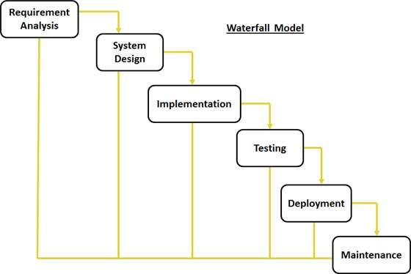

**5.1 SYSTEM ARCHITECTURE**

**LIBRARY MANAGEMENT SYSTEM**

**ADD BOOK**

**REPORTS**

**E-LIBRARY**

**REGISTRATION**

**ISSUE BOOK**

**REGISTRATION**

**BOOKS**

**ISSUE**

**VIEW**

**E-BOOKS**

**(PDF’S)**

**ADD**

**DELETE**

**SEARCH**

**UPDATE**

**COMPUTE**

**ADD**

**DELETE**

**SEARCH**

**UPDATE**

**ADD**

**DELETE**

**SEARCH**

**UPDATE**

**5.2 DATA FLOW DIAGRAM**

**LEVEL 0 DFD:**

**LIBRARY**

**ADMIN**

**LIBRARY**

**USER**

**LEVEL 1 DFD:**

**ADMIN**

**Is Valid?**

**BOOKS MAINTENANCE**

**BOOK ISSUE**

**RECORD**

**USER REGISTRATION**

**LIBRARY MANAGEMENT**

**GENERATE REPORT**

**LEVEL 2 DFD:**

**MEMBER**

**E-LIBRARY**

**INFORMATION**

**BOOK SEARCH**

**LIBRARY MANAGEMENT**

**5.3 E-R DIAGRAM**

BOOK

MEMBER

BORROWE

ISSUE

LIBRARIAN

**5.4 TABLES**

**Login Table:**

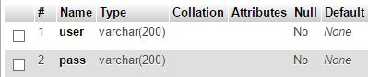

**Books Table:**

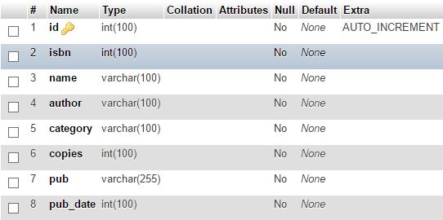

**Issue Table:**

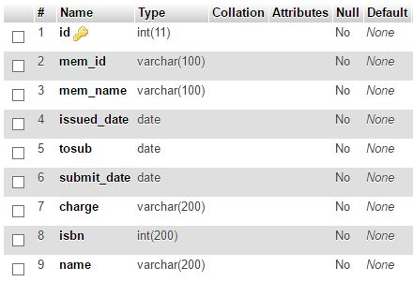

**Category Table:**

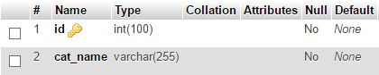

**Student table:**

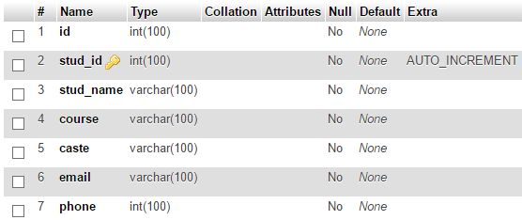

**Staff Table:**

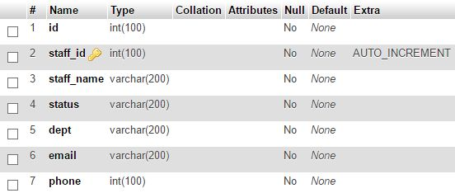

**6.1 TESTING INTRODUCTION**

**USER ACCEPTANCE TESTING:**

User acceptance testing (UAT) is the last phase of the software testing process. During UAT, actual software users test the software to make sure it can handle required tasks in real-world scenarios, according to specifications.

UAT is one of the final and critical software project procedures that must occur before newly developed software is rolled out to the market.

UAT is also known as beta testing, application testing or end user testing.

**ACCEPTANCE TESTING:**

**Acceptance Testing**is a [level of the software testing](http://softwaretestingfundamentals.com/software-testing-levels/) where a system is tested for acceptability.

The purpose of this test is to evaluate the system’s compliance with the business requirements and assess whether it is acceptable for delivery.

It is the formal testing with respect to user needs, requirements, and business processes conducted to determine whether or not a system satisfies the acceptance criteria and to enable the user, customers or other authorized entity to determine whether or not to accept the system.

**SOFTWARE TESTING:**

* Testing is the process of evaluating a system or its component(s) with the intent to find whether it satisfies the specified requirements or not.
* Testing is executing a system in order to identify any gaps, errors, or missing requirements in contrary to the actual requirements.

**TEST OBJECTIVE:**

* [**Finding defects**](http://istqbexamcertification.com/what-is-defect-or-bugs-or-faults-in-software-testing/) which may get created by the programmer while developing the software.
* Gaining confidence in and providing information about the level of [**quality**](http://istqbexamcertification.com/what-is-software-quality/).
* To prevent defects.
* To make sure that the end result meets the business and user requirements.
* To ensure that it satisfies the BRS that is Business Requirement Specification and SRS that is System Requirement Specifications.
* To gain the confidence of the customers by providing them a quality product.

Software testing helps in finalizing the software application or product against business and user requirements. It is very important to have good test coverage in order to test the software application completely and make it sure that it’s performing well and as per the specifications.

Software testing makes sure that the testing is being done properly and hence the system is ready for use. Good coverage means that the testing has been done to cover the various areas like functionality of the application, [compatibility](http://istqbexamcertification.com/what-is-compatibility-testing-in-software/)of the application with the OS, hardware and different types of browsers, [performancetesting](http://istqbexamcertification.com/what-is-performance-testing-in-software/) to test the performance of the application and [loadtesting](http://istqbexamcertification.com/what-is-load-testing-in-software/) to make sure that the system is reliable and should not crash or there should not be any blocking issues. It also determines that the application can be deployed easily to the machine and without any resistance. Hence the application is easy to install, learn and use.

**UNIT TESTING:**

Unit testing is a [software](http://searchsoa.techtarget.com/definition/software) development process in which the smallest testable parts of an [application](http://searchsoftwarequality.techtarget.com/definition/application), called units, are individually and independently scrutinized for proper operation. Unit testing can be done manually but is often [automated](http://searchitoperations.techtarget.com/definition/agile-test-automation-pyramid).

Unit testing involves only those characteristics that are vital to the performance of the unit under test. This encourages developers to modify the [sourcecode](http://searchsoa.techtarget.com/definition/source-code) without immediate concerns about how such changes might affect the functioning of other units or the program as a whole. Once all of the units in a program have been found to be working in the most efficient and error-free manner possible, larger components of the program can be evaluated by means of [integrationtesting](http://searchsoftwarequality.techtarget.com/definition/integration-testing).

**SYSTEM TESTING:**

System Testing (ST) is a black box testing technique performed to evaluate the complete system the system's compliance against specified requirements. In System testing, the functionalities of the system are tested from an end-to-end perspective.

System Testing is usually carried out by a team that is independent of the development team in order to measure the quality of the system unbiased. It includes both functional and Non-Functional testing.

**6.2 TEST CASE**

**LOGIN PROCESS:**

|  |  |  |  |
| --- | --- | --- | --- |
| **FIELD** | **VALUE** | **VALID/INVALID** | **RESULT** |
| User Name | Null | Invalid | Please Enter Username And Password |
| Password | Null | Invalid | Please Enter username and Password |
| Username | harish | Valid | Please Enter Valid username and Password |
| Password | manish | Invalid | Please Enter Valid username and Password |
| Username | harish | Valid | Redirect Towards the system |
| Password | Harishav | Valid | Redirect Towards the system |

**ADD BOOK:**

|  |  |  |  |
| --- | --- | --- | --- |
| **FIELD** | **VALUE** | **VALID/INVALID** | **RESULT** |
| ISBN | Null | Invalid | Please Enter ISBN |
| ISBN | 76586 | Invalid | Please Enter Valid ISBN |
| ISBN | 9789383214860 | Valid | Redirect Towards the system |
| Book Name | Null | Invalid | Please Enter Book Name |
| Book Name | DBMS-4 | Invalid | Please Enter Valid Book Name |
| Book Name | C++ | Valid | Redirect Towards the system |
| Author | Null | Invalid | Please Enter Author Name |
| Author | Manish1 | Invalid | Please Enter Valid Author Name |
| Author | Balaguru | Valid | Redirect Towards the system |
| Copies | Null | Invalid | Please Enter Number of Copies |
| Copies | 7o | Invalid | Please Enter Only Integers |
| Copies | 5 | Valid | Redirect Towards the system |

**EDIT BOOK:**

|  |  |  |  |
| --- | --- | --- | --- |
| **FIELD** | **VALUE** | **VALID/INVALID** | **RESULT** |
| ISBN | Null | Invalid | Please Enter ISBN To Search |
| ISBN | 9789383214860 | Valid | Redirect Towards the system |

**DELETE BOOK:**

|  |  |  |  |
| --- | --- | --- | --- |
| **FIELD** | **VALUE** | **VALID/INVALID** | **RESULT** |
| ISBN | Null | Invalid | Please Enter ISBN To Search |
| ISBN | 9789383214860 | Valid | Redirect Towards the system |

**ISSUE BOOK:**

|  |  |  |  |
| --- | --- | --- | --- |
| **FIELD** | **VALUE** | **VALID/INVALID** | **RESULT** |
| Publish Year | Null | Invalid | Please Enter ID |
| Publish Year | 150 | Invalid | Please Enter a Valid Year |
| Publish Year | 2017 | Valid | Redirect Towards the system |

**RETURN BOOK:**

|  |  |  |  |
| --- | --- | --- | --- |
| **FIELD** | **VALUE** | **VALID/INVALID** | **RESULT** |
| ID | Null | Invalid | Please Enter ID |
| ID | 6 | Valid | Redirect Towards the system |
| Charge | Null | Valid | Please Compute Fine Amount |
| Charge | 500 | Invalid | Redirect Towards the system |

**STUDENT REGISTRATION:**

|  |  |  |  |
| --- | --- | --- | --- |
| **FIELD** | **VALUE** | **VALID/INVALID** | **RESULT** |
| ID | Null | Invalid | Please Enter ID |
| ID | 5D | Invalid | Please Enter Valid ID |
| ID | 6 | Valid | Redirect Towards the system |
| Name | Null | Invalid | Please Enter Name |
| Name | Ramesh1 | Invalid | Please Enter Valid Name |
| Name | Satish | Valid | Redirect Towards the system |
| Email | Null | Invalid | Please Enter Email ID |
| Email | amangmail.com | Invalid | Please Enter Valid Email ID |
| Email | [satishk1@gmail.com](mailto:satishk1@gmail.com) | Valid | Redirect Towards the system |
| Phone No. | Null | Invalid | Please Enter a Phone Number |
| Phone No. | 2524 | Invalid | Please Enter a Valid Phone Number |
| Phone No. | 9449856743 | Valid | Redirect Towards the system |

**STAFF REGISTRATION:**

|  |  |  |  |
| --- | --- | --- | --- |
| **FIELD** | **VALUE** | **VALID/INVALID** | **RESULT** |
| ID | Null | Invalid | Please Enter ID |
| ID | 7s | Invalid | Please Enter Valid ID |
| ID | 5 | Valid | Redirect Towards the system |
| Name | Null | Invalid | Please Enter Name |
| Name | Anilk1 | Invalid | Please Enter Valid Name |
| Name | Manohar | Valid | Redirect Towards the system |
| Email | Null | Invalid | Please Enter Email ID |
| Email | devi.college.com | Invalid | Please Enter Valid Email ID |
| Email | usman@gmail.com | Valid | Redirect Towards the system |
| Phone No. | Null | Invalid | Please Enter a Phone Number |
| Phone No. | 9845 | Invalid | Please Enter a Valid Phone Number |
| Phone No. | 9449831756 | Valid | Redirect Towards the system |

**LOGIN FORM:**

<?php

include("loginserv.php"); // Include loginserv for checking username and password

?>

<!doctype html>

<html>

<meta charset="UTF-8">

<title>Login</title>

<div class="bar">

<img id="line" src="images/bar.png" />

</div>

<div class="line">

<img id="line" src="images/line2.png" />

</div>

<div class="logo1">

<img id="line" src="images/username.jpg" />

</div>

<div class="logo2">

<img id="line" src="images/password.jpg" />

</div>

<style>

.login{

position:absolute;

top:50px;

left:500px;

width:360px;

margin:50px auto;

border-radius:10px;

border:2px solid #ccc;

padding:10px 40px 25px;

margin-top:70px;

color:#6495ed;

}

input[type=text], input[type=password]{

position:relative;

top:0px;

width:260px;

height: 12px;

padding:10px;

margin-top:8px;

border:1px solid #ccc;

padding-left:5px;

font-size:16px;

}

input[type=submit]{

position:relative;

top:5px;

width:90%;

height:40px;

background-color:#6495ed;

color:white;

border:2px solid #06F;

padding:10px;

font-size:20px;

cursor:pointer;

border-radius:5px;

margin-bottom:10px;

}

.bar{

position:absolute;

top:0px;

left:0px;

}

.line{

position:absolute;

top:180px;

left:520px;

width:80px;

}

.forgot_pass{

position:absolute;

top:430px;

left:700px;

color:#6495ed;

}

h2{

color:#6495ed;

}

.logo1{

position:absolute;

top:220px;

left:542px;

}

.logo2{

position:absolute;

top:280px;

left:541px;

}

</style>

</head>

<body>

<div class="login">

<h1 align="center">LOGIN</h1>

<form action="" method="post" style="text-align:center;">

<input type="text" placeholder="Username" id="user" name="user" ><br/><br/>

<input type="password" placeholder="Password" id="pass" name="pass"><br/><br/>

<input type="submit" value="LOGIN" name="submit">

<!-- Error Message -->

<span><?php echo $error; ?></span>

</body>

</html>

**ADMIN HOME:**

<!DOCTYPE html>

<html>

<body>

<style>

body{

p­adding:0;

margin:0;

overflow-y:scroll;

font-family:Arial;

font-size:18px;

background-image: url("LOWRY.jpg");

background-color: #cccccc;

}

#nav{

background:#6495ed;

}

#nav_wrapper{

position:relative;

top:2px;

left:-80px;

width:800px;

margin:0 auto;

text-align:left;

}

#nav ul{

list-style-type:none;

padding:0;

margin:0;

position:relative;

}

#nav ul li{

display:inline-block;

}

#nav ul li:hover{

background-color:#333;

}

#nav ul li a,visited{

color:#ccc;

display:block;

padding:15px;

text-decoration:none;

}

#nav ul li a:hover {

color:#ccc;

text-decoration:none;

}

#nav ul li:hover ul{

display:block;

}

#nav ul ul{

display:none;

position:absolute;

background-color:#333;

border:5px solid #222;

border-top:0;

margin-left:-5px;

min-width:200px;

}

#nav ul ul li{

display:block;

}

#nav ul ul li a,visted{

color:#ccc;

}

#nav ul ul li a:hover{

color:#099;

}

#nav2{

background:#6495ed;

}

#nav2_wrapper{

position:absolute;

top:2px;

left:1000px;

width:300px;

margin:0 auto;

text-align:left;

}

#nav2 ul{

list-style-type:none;

padding:0;

margin:0;

position:relative;

}

#nav2 ul li{

display:inline-block;

}

#nav2 ul li:hover{

background-color:#333;

}

#nav2 ul li a,visited{

color:#ccc;

display:block;

padding:15px;

text-decoration:none;

}

#nav2 ul li a:hover {

color:#ccc;

text-decoration:none;

}

#nav2 ul li:hover ul{

display:block;

}

#nav2 ul ul{

display:none;

position:absolute;

background-color:#333;

border:5px solid #222;

border-top:0;

margin-left:-5px;

min-width:200px;

}

#nav2 ul ul li{

display:block;

}

#nav2 ul ul li a,visted{

color:#ccc;

}

#nav2 ul ul li a:hover{

color:#099;

}

#cover{

position:absolute;

top:50px;

left:100px;

}

</style>

</body>

</html>

<div id="nav">

<div id="nav_wrapper">

<ul>

<li><a href="admin_home.php">Home</a></li>

<li><a href="#">Modules</a>

<ul>

<li><a href ="ADD_BOOK.php">Add Book</a><li>

<li><a href ="MANAGE_BOOK.php">Manage Book</a><li>

<li><a href ="ADD_CATEGORY.php ">Add Category</a><li>

</ul>

</li>

<li><a href="#">Issue Books</a>

<ul>

<li><a href ="BOOK_ISSUE.php">New Book Issue</a><li>

<li><a href ="MANAGE_ISSUE.php">Manage Books Issued</a><li>

</ul>

</li>

<li><a href="#">Registration</a>

<ul>

<li><a href ="STAFFREG.php">Staff Registration</a><li>

<li><a href ="STUDENTREG.php">Student Registration</a><li>

<li><a href ="MANAGE_PROFILE.php">Manage Student/Staff Profile</a></li>

</ul>

</div>

</div>

<div id="nav2">

<div id="nav2_wrapper">

<ul>

<li><a href="#">Admin</a>

<ul>

<li><a href ="LOGIN.php">Logout</a><li>

</ul>

</li>

</div>

</div>

**ADD BOOK:**

<?php

$hostname = "localhost";

$username = "root";

$password = "";

$databaseName = "libpro";

$con = mysqli_connect($hostname, $username, $password, $databaseName);

$query = "SELECT * FROM `category`";

$result1 = mysqli_query($con, $query);

$options = "";

while($row1 = mysqli_fetch_array($result1))

{

$options = $options."<option>$row1[1]</option>";

}

if(isset($_POST['submit'])){

$name = $_POST['name'];

$author = $_POST['author'];

$isbn = $_POST['isbn'];

$category = $_POST['category'];

$copies = $_POST['copies'];

$pub = $_POST['pub'];

$pub_date = $_POST['pub_date'];

if(empty($name) || empty($author) || empty($isbn) || empty($category) || empty($copies) || empty($pub) || empty($pub_date))

{

echo '<div class="res">Please Enter All the Required fields</div> ';

header("Refresh: 1; url=ADD_BOOK.php");

}

else

{

$query ="insert into manage_books(name,author,isbn,category,copies,pub,pub_date) value ('$name','$author','$isbn','$category','$copies','$pub','$pub_date')";

if(mysqli_query($con,$query)){

echo '<div class="res">Record Inserted Successfully</div> ';

header("Refresh: 1; url=ADD_BOOK.php");

}

}

}

?>

<!DOCTYPE html>

<html>

<body>

<style>

.content_wrapper{

position:absolute;

top:50px;

left:5px;

width:1380px;

height:470px;

font-family:"Times New Roman";

font-size:"25";

}

.line{

position:absolute;

top:112px;

left:370px;

}

.col1{

position:absolute;

top:155px;

left:600px;

}

.col2{

position:absolute;

top:208px;

left:520px;

}

.col3{

position:absolute;

top:263px;

left:560px;

}

.col4{

position:absolute;

top:317px;

left:535px;

}

.col5{

position:absolute;

top:320px;

left:820px;

}

.col6{

position:absolute;

top:370px;

left:530px;

}

.col7{

position:absolute;

top:430px;

left:500px;

}

.booklist{

position:absolute;

top:410px;

left:1000px;

}

.text_boxes{

position:absolute;

top:170px;

left:680px;

}

.submit{

position:absolute;

top:500px;

left:420px;

}

.cancel{

position:absolute;

top:500px;

left:700px;

}

.status{

position:absolute;

top:335px;

left:910px;

}

.res{

position:absolute;

top:118px;

left:500px;

color:#6495ed;

display: block;

font-size: 26px;

margin-top: 1px;

margin-bottom: 0px;

text-align:center;

}

</style>

<form action="ADD_BOOK.php" method="post">

<div class="margin">

</div>

<div class="content_wrapper">

<center><h1>Add Book</h1><center>

</div>

<div class="line">

<img id="line" src="images/line.png" />

</div>

<div class="col1">

<h3>ISBN:</h3>

</div>

<div class="col2">

<h3>BOOK NAME:</h3>

</div>

<div class="col3">

<h3>AUTHOR:</h3>

</div>

<div class="col4">

<h3>CATEGORY:</h3>

</div>

<div class="col5">

<h3>COPIES:</h3>

</div>

<div class="col6">

<h3>PUBLISHER:</h3>

</div>

<div class="col7">

<h3>PUBLISH YEAR:</h3>

</div>

<div class="booklist">

<a href="BOOK_LIST.php"><img src="images\report.jpg"></a>

</div>

<div class="text_boxes">

<input type="text" name="isbn" size="30px" style="height: 27px;"/><br></br>

<input type="text" name="name" size="30px" style="height: 27px;"/><br></br>

<input type="text" name="author" size="30px" style="height: 27px;"/><br></br>

<select name="category" style="height: 35px;"/><br>

<?php echo $options;?>

</select><br></br>

<input type="text" name="pub" size="30px" style="height: 27px;"/><br></br>

<input type="text" name="pub_date" size="30px" style="height: 27px;"/><br></br>

</div>

<div class="status">

<input type="text" name="copies" size="5px" style="height: 27px;"/><br></br>

</div>

<div class="submit">

<a href="ADD_BOOK.php">

<input type="submit" name="submit" value="SUBMIT" class="btn btn-success" onclick="return confirm('Are you sure you want to Add this Record?')" style="height:50px; width:150px" /></a>

</div>

<div class="cancel">

<a href="admin_home.php">

<input type="button" name="cancel" value="CANCEL" class="btn btn-success" style="height:50px; width:150px" /></a>

</div>

</form>

</html>

**EDIT BOOK:**

<?php

$host = "localhost";

$user = "root";

$password ="";

$database = "libpro";

$isbn = "";

$name = "";

$author = "";

$category= "";

$copies="";

$pub="";

$pub_date="";

mysqli_report(MYSQLI_REPORT_ERROR | MYSQLI_REPORT_STRICT);

try{

$connect = mysqli_connect($host, $user, $password, $database);

} catch (mysqli_sql_exception $ex) {

echo 'Error';

}

function getPosts()

{

$posts=array();

$posts[1]=$_POST['isbn'];

$posts[2]=$_POST['name'];

$posts[3]=$_POST['author'];

$posts[4]=$_POST['category'];

$posts[5]=$_POST['copies'];

$posts[6]=$_POST['pub'];

$posts[7]=$_POST['pub_date'];

return $posts;

}

if(isset($_POST['search'])){

$data=getPosts();

$search_Query = "SELECT * FROM manage_books WHERE isbn = $data[1]";

$search_Result = mysqli_query ($connect,$search_Query);

if($search_Result)

{

if(mysqli_num_rows($search_Result))

{

while($row=mysqli_fetch_array($search_Result))

{

$isbn=$row['isbn'];

$name=$row['name'];

$author=$row['author'];

$category=$row['category'];

$copies=$row['copies'];

$pub=$row['pub'];

$pub_date=$row['pub_date'];

}

}else{

echo '<div class="res">No Data For This ID</div> ';

header("Refresh: 1; url=EDIT_BOOK.php");

}

}else{

echo '<div class="res">Result Error</div> ';

header("Refresh: 1; url=EDIT_BOOK.php");

}

}

if(isset($_POST['update']))

{

$data = getPosts();

$update_Query = "UPDATE `manage_books` SET `name`='$data[2]',`author`='$data[3]',`category`='$data[4]',`copies`='$data[5]',`pub`='$data[6]',`pub_date`='$data[7]' WHERE `isbn` = $data[1]";

try{

$update_Result = mysqli_query($connect, $update_Query);

if($update_Result)

{

if(mysqli_affected_rows($connect) > 0)

{

echo '<div class="res">Record Updated Successfully</div> ';

header("Refresh: 1; url=EDIT_BOOK.php");

}else{

echo '<div class="res">Record Updated Successfully</div> ';

header("Refresh: 1; url=EDIT_BOOK.php");

}

}

} catch (Exception $ex) {

echo '<div class="res">Error Update</div> ';

header("Refresh: 1; url=EDIT_BOOK.php");

}

}

?>

<!DOCTYPE html>

<html>

<body>

<style>

.res{

position:absolute;

top:115px;

left:500px;

color:#6495ed;

display: block;

font-size: 26px;

margin-top: 1px;

margin-bottom: 0px;

text-align:center;

}

.content_wrapper{

position:absolute;

top:50px;

left:5px;

width:1380px;

height:470px;

font-family:"Times New Roman";

font-size:"25";

}

.line{

position:absolute;

top:110px;

left:370px;

}

.fields1{

position:absolute;

top:155px;

left:505px;

}

.fields2{

position:absolute;

top:205px;

left:502px;

}

.fields3{

position:absolute;

top:263px;

left:545px;

}

.fields4{

position:absolute;

top:317px;

left:520px;

}

.col5{

position:absolute;

top:375px;

left:480px;

}

.col6{

position:absolute;

top:430px;

left:520px;

}

.col7{

position:absolute;

top:480px;

left:490px;

}

.text_boxes{

position:absolute;

top:170px;

left:674px;

}

.submit{

position:absolute;

top:560px;

left:420px;

}

.cancel{

position:absolute;

top:560px;

left:700px;

}

.find{

position:absolute;

top:170px;

left:770px;

}

.status{

position:absolute;

top:390px;

left:675px;

}

</style>

<form action="EDIT_BOOK.php" method="post">

<div class="margin">

</div>

<div class="content_wrapper">

<center><h1>Edit Book</h1><center>

</div>

<div class="line">

<img id="line" src="images/line.png" />

</div>

<div class="fields1">

<h3>ENTER ISBN:</h3>

</div>

<div class="fields2">

<h3>BOOK NAME:</h3>

</div>

<div class="fields3">

<h3>AUTHOR:</h3>

</div>

<div class="fields4">

<h3>CATEGORY:</h3>

</div>

<div class="col5">

<h3>NO. OF COPIES:</h3>

</div>

<div class="col6">

<h3>PUBLISHER:</h3>

</div>

<div class="col7">

<h3>PUBLISH DATE:</h3>

</div>

<div class="text_boxes">

<input type="text" name="isbn" placeholder="isbn" value="<?php echo $isbn;?>" size="10px" style="height: 27px;"><br></br>

<input type="text" name="name" placeholder="name" value="<?php echo $name;?>"size="30px" style="height: 27px;"><br></br>

<input type="text" name="author" placeholder="author" value="<?php echo $author;?>" size="30px" style="height: 27px;"><br></br>

<input type="text" name="category" placeholder="category" value="<?php echo $category;?>" size="30px" style="height: 27px;"><br></br>

<input type="text" name="copies" placeholder="Copies" value="<?php echo $copies;?>" size="5px" style="height: 27px;"/><br></br>

<input type="text" name="pub" placeholder="publisher" value="<?php echo $pub;?>" size="30px" style="height: 27px;"/><br></br>

<input type="text" name="pub_date" placeholder="publish date" value="<?php echo $pub_date;?>" size="30px" style="height: 27px;"/><br></br>

</div>

<div class="find">

<input type="submit" name="search" value="FIND" style="height:33px" />

</div>

<div class="submit">

<a href="EDIT_BOOK.php">

<input type="submit" name="update" value="UPDATE" onclick="return confirm('Are you sure you want you want to Update this record?')" style="height:50px; width:150px" /></a>

</div>

<div class="cancel">

<a href="admin_home.php">

<input type="button" name="cancel" value="CANCEL" style="height:50px; width:150px" ></a>

</div>

</form>

</body>

</html>

**DELETE BOOK:**

<?php

$host = "localhost";

$user = "root";

$password ="";

$database = "libpro";

$isbn = "";

$name = "";

$author = "";

$category= "";

$copies="";

$pub="";

$pub_date="";

mysqli_report(MYSQLI_REPORT_ERROR | MYSQLI_REPORT_STRICT);

try{

$connect = mysqli_connect($host, $user, $password, $database);

} catch (mysqli_sql_exception $ex) {

echo 'Error';

}

function getPosts()

{

$posts=array();

$posts[1]=$_POST['isbn'];

$posts[2]=$_POST['name'];

$posts[3]=$_POST['author'];

$posts[4]=$_POST['category'];

$posts[5]=$_POST['copies'];

$posts[6]=$_POST['pub'];

$posts[7]=$_POST['pub_date'];

return $posts;

}

if(isset($_POST['search'])){

$data=getPosts();

$search_Query = "SELECT * FROM manage_books WHERE isbn = $data[1]";

$search_Result = mysqli_query ($connect,$search_Query);

if($search_Result)

{

if(mysqli_num_rows($search_Result))

{

while($row=mysqli_fetch_array($search_Result))

{

$isbn=$row['isbn'];

$name=$row['name'];

$author=$row['author'];

$category=$row['category'];

$copies=$row['copies'];

$pub=$row['pub'];

$pub_date=$row['pub_date'];

}

}else{

echo '<div class="res">No Data For This ID</div> ';

header("Refresh: 1; url=DELETE_BOOK.php");

}

}else{

echo '<div class="res">Result Error</div> ';

header("Refresh: 1; url=DELETE_BOOK.php");

}

}

if(isset($_POST['delete']))

{

$data = getPosts();

$delete_Query = "DELETE FROM `manage_books` WHERE `isbn` = $data[1]";

try{

$delete_Result = mysqli_query($connect, $delete_Query);

if($delete_Result)

{

if(mysqli_affected_rows($connect) > 0)

{

echo '<div class="res">Record Deleted Successfully</div> ';

header("Refresh: 1; url=DELETE_BOOK.php");

}

else{

echo '<div class="res">Record Not Deleted Successfully</div> ';

header("Refresh: 1; url=DELETE_BOOK.php");

}

}

} catch (Exception $ex) {

echo '<div class="res">Error Delete</div> ';

header("Refresh: 1; url=DELETE_BOOK.php");

}

}

?>

<!DOCTYPE html>

<html>

<head>

<body>

<style>

.res{

position:absolute;

top:115px;

left:500px;

color:#6495ed;

display: block;

font-size: 26px;

margin-top: 1px;

margin-bottom: 0px;

text-align:center;

}

.content_wrapper{

position:absolute;

top:50px;

left:5px;

width:1380px;

height:470px;

font-family:"Times New Roman";

font-size:"25";

}

.line{

position:absolute;

top:110px;

left:370px;

}

.fields1{

position:absolute;

top:155px;

left:505px;

}

.fields2{

position:absolute;

top:205px;

left:502px;

}

.fields3{

position:absolute;

top:263px;

left:545px;

}

.fields4{

position:absolute;

top:317px;

left:520px;

}

.col5{

position:absolute;

top:375px;

left:480px;

}

.col6{

position:absolute;

top:430px;

left:520px;

}

.col7{

position:absolute;

top:480px;

left:490px;

}

.text_boxes{

position:absolute;

top:170px;

left:674px;

}

.submit{

position:absolute;

top:560px;

left:420px;

}

.cancel{

position:absolute;

top:560px;

left:700px;

}

.find{

position:absolute;

top:170px;

left:770px;

}

.status{

position:absolute;

top:390px;

left:675px;

}

</style>

<form action="DELETE_BOOK.php" method="post">

<div class="margin">

</div>

<div class="content_wrapper">

<center><h1>Delete Book</h1><center>

</div>

<div class="line">

<img id="line" src="images/line.png" />

</div>

<div class="fields1">

<h3>ENTER ISBN:</h3>

</div>

<div class="fields2">

<h3>BOOK NAME:</h3>

</div>

<div class="fields3">

<h3>AUTHOR:</h3>

</div>

<div class="fields4">

<h3>CATEGORY:</h3>

</div>

<div class="col5">

<h3>NO. OF COPIES:</h3>

</div>

<div class="col6">

<h3>PUBLISHER:</h3>

</div>

<div class="col7">

<h3>PUBLISH DATE:</h3>

</div>

<div class="text_boxes">

<input type="text" name="isbn" placeholder="isbn" value="<?php echo $isbn;?>" size="10px" style="height: 27px;"><br></br>

<input type="text" name="name" placeholder="name" value="<?php echo $name;?>"size="30px" style="height: 27px;"><br></br>

<input type="text" name="author" placeholder="author" value="<?php echo $author;?>" size="30px" style="height: 27px;"><br></br>

<input type="text" name="category" placeholder="category" value="<?php echo $category;?>" size="30px" style="height: 27px;"><br></br>

<input type="text" name="copies" placeholder="Copies" value="<?php echo $copies;?>" size="5px" style="height: 27px;"/><br></br>

<input type="text" name="pub" placeholder="publisher" value="<?php echo $pub;?>" size="30px" style="height: 27px;"/><br></br>

<input type="text" name="pub_date" placeholder="publish date" value="<?php echo $pub_date;?>" size="30px" style="height: 27px;"/><br></br>

</div>

<div class="find">

<input type="submit" name="search" value="FIND" style="height:33px" />

</div>

<div class="submit">

<a href="DELETE_BOOK.php">

<input type="submit" name="delete" value="DELETE" onclick="return confirm('Are you sure you want to Delete this record?')" style="height:50px; width:150px " /></a>

</div>

<div class="cancel">

<a href="admin_home.php">

<input type="button" name="cancel" value="CANCEL" style="height:50px; width:150px" /></a>

</div>

</form>

</body>

</html>

**NEWBOOK ISSUE:**

<?php

$host = "localhost";

$user = "root";

$password ="";

$database = "libpro";

$stud_id = "";

$stud_name = "";

$staff_id="";

$staff_name="";

$mem_id = "";

$mem_name = "";

$issued_date = "";

$tosub="";

$isbn="";

$name = "";

mysqli_report(MYSQLI_REPORT_ERROR | MYSQLI_REPORT_STRICT);

try{

$connect = mysqli_connect($host, $user, $password, $database);

} catch (mysqli_sql_exception $ex) {

echo 'Error';

}

$query = "SELECT * FROM `manage_books`";

$result1 = mysqli_query($connect, $query);

$options = "";

while($row1 = mysqli_fetch_array($result1))

{

$options = $options."<option>$row1[2]</option>";

}

function getPosts()

{

$posts=array();

$posts[1]=$_POST['mem_id'];

$posts[2]=$_POST['mem_name'];

return $posts;

}

function getPosts2()

{

$posts2=array();

$posts2[1]=$_POST['mem_id'];

$posts2[2]=$_POST['mem_name'];

return $posts2;

}

function getPosts3()

{

$posts3=array();

$posts3[1]=$_POST['isbn'];

$posts3[2]=$_POST['name'];

return $posts3;

}

if(isset($_POST['find'])){

$data=getPosts();

$search_Query = "SELECT stud_id,stud_name FROM stud_reg WHERE stud_id= $data[1]";

$search_Result = mysqli_query ($connect,$search_Query);

if($search_Result)

{

if(mysqli_num_rows($search_Result))

{

while($row=mysqli_fetch_array($search_Result))

{

$mem_id=$row['stud_id'];

$mem_name=$row['stud_name'];

}

}else{

echo '<div class="res">No Data For This ID</div> ';

header("Refresh: 1; url=BOOK_ISSUE.php");

}

}else{

echo '<div class="res">Result Error</div> ';

header("Refresh: 1; url=BOOK_ISSUE.php");

}

}

if(isset($_POST['find2'])){

$data=getPosts2();

$search_Query = "SELECT staff_id ,staff_name FROM staff_reg WHERE staff_id= $data[1]";

$search_Result = mysqli_query ($connect,$search_Query);

if($search_Result)

{

if(mysqli_num_rows($search_Result))

{

while($row=mysqli_fetch_array($search_Result))

{

$mem_id=$row['staff_id'];

$mem_name=$row['staff_name'];

}

}else{

echo '<div class="res">No Data For This ID</div> ';

header("Refresh: 1; url=BOOK_ISSUE.php");

}

}else{

echo '<div class="res">Result Error</div> ';

header("Refresh: 1; url=BOOK_ISSUE.php");

}

}

if(isset($_POST['submit'])){

$mem_id = $_POST['mem_id'];

$mem_name = $_POST['mem_name'];

$issued_date = $_POST['issued_date'];

$tosub=$_POST['tosub'];

$name = $_POST['name'];

$query ="INSERT INTO new_book (mem_id,mem_name,issued_date,tosub,name) value ('$mem_id','$mem_name','$issued_date','$tosub','$name')";

if(mysqli_query($connect,$query)){

echo '<div class="res">Record Inserted Successfully</div> ';

header("Refresh: 1; url=BOOK_ISSUE.php");

}

else{

echo '<div class="res">Record Not Inserted Successfully</div> ';

header("Refresh: 1; url=BOOK_ISSUE.php");

}

}

?>

<!DOCTYPE html>

<html>

<body>

<style>

.content_wrapper{

position:absolute;

top:40px;

left:20px;

width:1380px;

height:470px;

font-family:"Times New Roman";

font-size:"25";

}

.line{

position:absolute;

top:105px;

left:370px;

}

.fields1{

position:absolute;

top:155px;

left:460px;

}

.fields2{

position:absolute;

top:208px;

left:420px;

}

.fields3{

position:absolute;

top:263px;

left:535px;

}

.fields4{

position:absolute;

top:320px;

left:450px;

}

.fields6{

position:absolute;

top:370px;

left:455px;

}

.text_boxes{

position:absolute;

top:170px;

left:750px;

}

.submit{

position:absolute;

top:500px;

left:420px;

}

.cancel{

position:absolute;

top:500px;

left:700px;

}

.find{

position:absolute;

top:170px;

left:855px;

}

.find2{

position:absolute;

top:382px;

left:925px;

}

.book{

position:absolute;

top:350px;

left:590px;

}

.res{

position:absolute;

top:115px;

left:500px;

color:#6495ed;

display: block;

font-size: 26px;

margin-top: 1px;

margin-bottom: 0px;

text-align:center;

}

.issuelist{

position:absolute;

top:450px;

left:1050px;

}

</style>

<form action="BOOK_ISSUE.php" method="post">

<div class="margin">

</div>

<div class="content_wrapper">

<center><h1>New Book Issue</h1></center>

</div>

<div class="line">

<img id="line" src="images/line.png" />

</div>

<div class="fields1">

<h3>STUDENT/STAFF ID:</h3>

</div>

<div class="fields2">

<h3>STUDENT/STAFF NAME:</h3>

</div>

<div class="fields3">

<h3>ISSUE DATE:</h3>

</div>

<div class="fields4">

<h3>SUBMMISSION DATE:</h3>

</div>

<div class="fields6">

<h3>BOOK BORROWING:</h3>

</div>

<div class="text_boxes">

<input type="text" name="mem_id" placeholder="id" value="<?php echo $mem_id;?>" size="10px" style="height: 27px;"/><br></br>

<input type="text" name="mem_name"placeholder="name" value="<?php echo $mem_name;?>" size="30px" style="height: 27px;"/><br></br>

<input type="date" name="issued_date" value="<?php echo date('Y-m-d'); ?>" style="height: 27px;"/><br></br>

<input type="date" name="tosub" style="height: 27px;"/><br></br>

<select name="name" style="height: 35px; width : 200px"/><br>

<?php echo $options;?>

</select><br></br>

</div>

<div class="find">

<input type="submit" name="find" value="FIND STUDENT" style="height:33px; width:110px" />

<input type="submit" name="find2" value="FIND STAFF" style="height:33px; width:110px" />

</div>

<div class="submit">

<input type="submit" name="submit" value="SUBMIT" onclick="return confirm('Are you sure you want to add this Record?')" style="height:50px; width:150px" />

</div>

<div class="cancel">

<a href="admin_home.php">

<input type="button" name="cancel" value="CANCEL" style="height:50px; width:150px" /></a>

</div>

<div class="issuelist">

<a href="issuelist.php"><img src="images\report.jpg"></a>

</div>

</form>

</body>

</html>

**MANAGE ISSUE:**

<?php

$host = "localhost";

$user = "root";

$password ="";

$database = "libpro";

$mem_id = "";

$mem_name = "";

$issued_date = "";

$tosub = "";

$submit_date= "";

$charge= "";

$name= "";

$fine="";

mysqli_report(MYSQLI_REPORT_ERROR | MYSQLI_REPORT_STRICT);

try{

$connect = mysqli_connect($host, $user, $password, $database);

} catch (mysqli_sql_exception $ex) {

echo 'Error';

}

function getPosts()

{

$posts=array();

$posts[1]=$_POST['mem_id'];

$posts[2]=$_POST['mem_name'];

$posts[3]=$_POST['issued_date'];

$posts[4]=$_POST['tosub'];

$posts[5]=$_POST['submited_date'];

$posts[6]=$_POST['charge'];

$posts[8]=$_POST['name'];

return $posts;

}

function get()

{

$start = $_POST['tosub'];

$end = $_POST['submited_date'];

if ($end < $start)

{

echo 'Submitted Date Invalid';

}

else

{

$diff=(strtotime($end)- strtotime($start))/24/3600;

$fine=$diff*50;

echo $fine;

}

}

if(isset($_POST['search'])){

$data=getPosts();

$search_Query = "SELECT * FROM new_book WHERE mem_id= $data[1]";

$search_Result = mysqli_query ($connect,$search_Query);

if($search_Result)

{

if(mysqli_num_rows($search_Result))

{

while($row=mysqli_fetch_array($search_Result))

{

$mem_id=$row['mem_id'];

$mem_name=$row['mem_name'];

$issued_date=$row['issued_date'];

$tosub=$row['tosub'];

$submit_date=$row['submit_date'];

$charge=$row['charge'];

$name=$row['name'];

}

}else{

echo '<div class="res">No Data For This ID</div> ';

header("Refresh: 1; url=MANAGE_ISSUE.php");

}

}else{

echo '<div class="res">Result Error</div> ';

header("Refresh: 1; url=MANAGE_ISSUE.php");

}

}

if(isset($_POST['update']))

{

$data = getPosts();

$update_Query = "UPDATE `new_book` SET `mem_name`='$data[2]',`issued_date`='$data[3]',`tosub`='$data[4]',`submit_date`='$data[5]',`charge`='$data[6]',`name`='$data[8]' WHERE `mem_id` = $data[1]";

try{

$update_Result = mysqli_query($connect, $update_Query);

if($update_Result)

{

if(mysqli_affected_rows($connect) > 0)

{

echo '<div class="res">Record Updated Successfully</div> ';

header("Refresh: 1; url=MANAGE_ISSUE.php");

}else{

echo '<div class="res">Record Not Updated Successfully</div> ';

header("Refresh: 1; url=MANAGE_ISSUE.php");

}

}

} catch (Exception $ex) {

echo '<div class="res">Error Update</div> ';

header("Refresh: 1; url=MANAGE_ISSUE.php");

}

}

?>

<!DOCTYPE html>

<html>

<body>

<style>

.content_wrapper{

position:absolute;

top:40px;

left:20px;

width:1380px;

height:470px;

font-family:"Times New Roman";

font-size:"25";

}

.line{

position:absolute;

top:105px;

left:370px;

}

.fields1{

position:absolute;

top:155px;

left:457px;

}

.fields2{

position:absolute;

top:208px;

left:417px;

}

.fields3{

position:absolute;

top:263px;

left:530px;

}

.fields4{

position:absolute;

top:320px;

left:440px;

}

.fields5{

position:absolute;

top:380px;

left:480px;

}

.fields6{

position:absolute;

top:425px;

left:500px;

}

.fields7{

position:absolute;

top:470px;

left:458px;

}

.text_boxes{

position:absolute;

top:170px;

left:750px;

}

.submit{

position:absolute;

top:550px;

left:420px;

}

.cancel{

position:absolute;

top:550px;

left:700px;

}

.fetch{

position:absolute;

top:350px;

left:270px;

}

.find{

position:absolute;

top:170px;

left:855px;

}

.book{

position:absolute;

top:350px;

left:590px;

}

.res{

position:absolute;

top:115px;

left:500px;

color:#6495ed;

display: block;

font-size: 26px;

margin-top: 1px;

margin-bottom: 0px;

text-align:center;

}

</style>

<form action="MANAGE_ISSUE.php" method="post">

<div class="content_wrapper">

<center><h1>Return Book Issue</h1></center>

</div>

<div class="line">

<img id="line" src="images/line.png" />

</div>

<div class="fields1">

<h3>STUDENT/STAFF ID:</h3>

</div>

<div class="fields2">

<h3>STUDENT/STAFF NAME:</h3>

</div>

<div class="fields3">

<h3>ISSUE DATE:</h3>

</div>

<div class="fields4">

<h3>SUBMMISSION DATE:</h3>

</div>

<div class="fields5">

<h3>SUBMITED DATE:</h3>

</div>

<div class="fields6">

<h3>LATE CHARGE:</h3>

</div>

<div class="fields7">

<h3>BOOK BORROWED:</h3>

</div>

<div class="margin">

</div>

<div class="text_boxes">

<input type="text" name="mem_id" placeholder="mem_id" value="<?php echo $mem_id;?>" size="10px" style="height: 27px;"/><br></br>

<input type="text" name="mem_name" placeholder="mem_name" value="<?php echo $mem_name;?>" size="30px" style="height: 27px;"/><br></br>

<input type="text" name="issued_date" placeholder="issued_date" value="<?php echo $issued_date;?>" size="30px"style="height: 27px;"/><br></br>

<input type="text" name="tosub" placeholder="submission_date" value="<?php echo $tosub;?>" size="30px"style="height: 27px;"/><br></br>

<input type="date" name="submited_date" placeholder="submit_date" value="<?php echo date('Y-m-d'); ?>" size="30px" style="height: 27px;"/><br></br>

<input type="text" name="charge" placeholder="charge" value="<?php echo $fine;?>" size="10px" style="height: 27px;"/><br></br>

<input type="text" name="name" placeholder="name" value="<?php echo $name;?>" size="30px" style="height: 27px;"/><br></br>

</div>

<div class="find">

<input type="submit" name="search" value="FIND" style="height:33px; width:110px" /></a>

</div>

<div class="submit">

<a href="MANAGE_ISSUE.php">

<input type="submit" name="update" value="UPDATE" style="height:50px; width:150px" /></a>

</div>

<div class="cancel">

<a href="admin_home.php">

<input type="button" name="cancel" value="CANCEL" style="height:50px; width:150px" /></a>

</div>

</table>

</div>

</form>

</body>

</html>

**STAFF REGISTRATION:**

<?php

$con=mysqli_connect('localhost','root','','libpro');

if(isset($_POST['submit'])){

$id = $_POST['id'];

$name = $_POST['name'];

$status = $_POST['status'];

$department = $_POST['department'];

$email = $_POST['email'];

$phone = $_POST['phone'];

$query ="insert into staff_reg (staff_id,staff_name,status,dept,email,phone) value ('$id','$name','$status','$department','$email','$phone')";

if(mysqli_query($con,$query)){

echo '<div class="res">Record Inserted Successfully</div> ';

header("Refresh: 1; url=STAFFREG.php");

}

else{

echo '<div class="res">Record Not Inserted Successfully</div> ';

header("Refresh: 1; url=STAFFREG.php");

}

}

}

?>

<!DOCTYPE html>

<html>

<body>

<style>

.res{

position:absolute;

top:124px;

left:500px;

color:#6495ed;

display: block;

font-size: 26px;

margin-top: 1px;

margin-bottom: 0px;

text-align:center;

}

.content_wrapper{

position:absolute;

top:50px;

left:5px;

width:1380px;

height:470px;

font-family:"Times New Roman";

font-size:"25";

}

.line{

position:absolute;

top:115px;

left:370px;

}

.fields1{

position:absolute;

top:155px;

left:520px;

}

.fields2{

position:absolute;

top:208px;

left:480px;

}

.fields3{

position:absolute;

top:263px;

left:530px;

}

.fields4{

position:absolute;

top:317px;

left:475px;

}

.fields5{

position:absolute;

top:375px;

left:550px;

}

.fields6{

position:absolute;

top:430px;

left:542px;

}

.text_boxes1{

position:absolute;

top:170px;

left:680px;

}

.text_boxes2{

position:absolute;

top:225px;

left:680px;

}

.text_boxes3{

position:absolute;

top:280px;

left:680px;

}

.text_boxes4{

position:absolute;

top:330px;

left:680px;

}

.text_boxes5{

position:absolute;

top:390px;

left:680px;

}

.text_boxes6{

position:absolute;

top:445px;

left:680px;

}

.submit{

position:absolute;

top:520px;

left:420px;

}

.cancel{

position:absolute;

top:520px;

left:700px;

}

.stafflist{

position:absolute;

top:410px;

left:1050px;

}

</style>

<form action="STAFFREG.php" method="post">

<div class="margin">

</div>

<div class="content_wrapper">

<center><h1>Staff Registration</h1><center>

</div>

<div class="line">

<img id="line" src="images/line.png" />

</div>

<div class="fields1">

<h3>STAFF ID:</h3>

</div>

<div class="fields2">

<h3>STAFF NAME:</h3>

</div>

<div class="fields3">

<h3>STATUS:</h3>

</div>

<div class="fields4">

<h3>DEPARTMENT:</h3>

</div>

<div class="fields5">

<h3>EMAIL:</h3>

</div>

<div class="fields6">

<h3>PHONE:</h3>

</div>

<div class="text_boxes1">

<input type="text" name="id" size="30px" style="height: 27px;"/><br></br>

</div>

<div class="text_boxes2">

<input type="text" name="name" size="30px" style="height: 27px;"/><br></br>

</div>

<div class="text_boxes3">

<select name="status" style="height: 35px;"/><br>

<option>Teaching</option>

<option>Non-Teaching</option>

</select><br></br>

</div>

<div class="text_boxes4">

<select name="department" width="100px" style="height: 35px;"/><br>

<option>Computer Science</option>

<option>Management</option>

<option>Commerce</option>

</select><br></br>

</div>

<div class="text_boxes5">

<input type="text" name="email" size="30px" style="height: 27px;"/><br></br>

</div>

<div class="text_boxes6">

<input type="text" name="phone" size="30px" style="height: 27px;"/><br></br>

</div>

<div class="submit">

<a href="STAFFREG.php">

<input type="submit" name="submit" value="SUBMIT" onclick="return confirm('Are you sure you want to Add this record?')" style="height:50px; width:150px" /></a>

</div>

<div class="cancel">

<a href="admin_home.php">

<input type="button" name="cancel" value="CANCEL" style="height:50px; width:150px" /></a>

</div>

<div class="stafflist">

<a href="Selectstaff.php"><img src="images\report.jpg"></a>

</div>

</form>

</body>

</html>

**STUDENT REGISTRATION:**

<?php

$con=mysqli_connect('localhost','root','','libpro');

$name="";

if(isset($_POST['submit'])){

$name = $_POST['name'];

$courses = $_POST['courses'];

$caste = $_POST['caste'];

$phone = $_POST['phone'];

$email = input($_POST["email"]);

$query ="insert into stud_reg (stud_id,stud_name,course,caste,email,phone) value ('$id','$name','$courses','$caste','$email','$phone')";

if(mysqli_query($con,$query)){

echo '<div class="res">Record Inserted Successfully</div> ';

header("Refresh: 1; url=STUDENTREG.php");

}

else{

echo '<div class="res">Record Not Inserted Successfully</div> ';

header("Refresh: 1; url=STUDENTREG.php");

}

}

}

?>

<!DOCTYPE html>

<html>

<body>

<style>

.res{

position:absolute;

top:125px;

left:500px;

color:#6495ed;

display: block;

font-size: 26px;

margin-top: 1px;

margin-bottom: 0px;

text-align:center;

}

.content_wrapper{

position:absolute;

top:50px;

left:5px;

width:1380px;

height:470px;

font-family:"Times New Roman";

font-size:"25";

}

.line{

position:absolute;

top:115px;

left:370px;

}

.fields1{

position:absolute;

top:155px;

left:520px;

}

.fields2{

position:absolute;

top:208px;

left:480px;

}

.fields3{

position:absolute;

top:263px;

left:450px;

}

.fields4{

position:absolute;

top:317px;

left:475px;

}

.fields5{

position:absolute;

top:375px;

left:460px;

}

.fields6{

position:absolute;

top:430px;

left:572px;

}

.text_boxes{

position:absolute;

top:170px;

left:680px;

}

.submit{

position:absolute;

top:520px;

left:420px;

}

.cancel{

position:absolute;

top:520px;

left:700px;

}

.studlist{

position:absolute;

top:410px;

left:1050px;

}

</style>

<form action="STUDENTREG.php" method="post">

<div class="content_wrapper">

<center><h1>Student Registration</h1><center>

</div>

<div class="line">

<img id="line" src="images/line.png" />

</div>

<div class="fields1">

<h3>STUDENT ID:</h3>

</div>

<div class="fields2">

<h3>STUDENT NAME:</h3>

</div>

<div class="fields3">

<h3>STUDENT COURSE:</h3>

</div>

<div class="fields4">

<h3>STUDENT CASTE:</h3>

</div>

<div class="fields5">

<h3>EMAIL(OPTIONAL):</h3>

</div>

<div class="fields6">

<h3>PHONE:</h3>

</div>

<div class="margin">

</div>

<div class="text_boxes">

<input type="text" name="id" size="30px" style="height: 27px;"/><br></br>

<input type="text" name="name" size="30px" style="height: 27px;"/><br></br>

<select name="courses" style="height: 35px;"/><br>

<option>BCA</option>

<option>BCOM</option>

<option>BBM</option>

<option>MCA</option>

</select><br></br>

<select name="caste" width="100px" style="height: 35px;"/><br>

<option>SC</option>

<option>ST</option>

<option>OBC</option>

<option>FC</option>

</select><br></br>

<input type="text" name="email" size="30px" style="height: 27px;"/><br></br>

<input type="text" name="phone" size="30px" style="height: 27px;"/><br></br>

</div>

<div class="submit">

<a href="STUDENTREG.php">

<input type="submit" name="submit" value="SUBMIT" onclick="return confirm('Are you sure you want to add this Record?')" style="height:50px; width:150px" /></a><br>

</div>

<div class="cancel">

<a href="admin_home.php">

<input type="button" name="cancel" value="CANCEL" style="height:50px; width:150px" /></a><br>

</div>

<div class="studlist">

<a href="Selectstud.php"><img src="images\report.jpg"></a>

</div>

</form>

</body>

</html>

**EDIT STAFF:**

<?php

$host = "localhost";

$user = "root";

$password ="";

$database = "libpro";

$staff_id = "";

$staff_name = "";

$status = "";

$dept= "";

$email= "";

$phone= "";

mysqli_report(MYSQLI_REPORT_ERROR | MYSQLI_REPORT_STRICT);

try{

$connect = mysqli_connect($host, $user, $password, $database);

} catch (mysqli_sql_exception $ex) {

echo 'Error';

}

function getPosts()

{

$posts=array();

$posts[1]=$_POST['staff_id'];

$posts[2]=$_POST['staff_name'];

$posts[3]=$_POST['status'];

$posts[4]=$_POST['dept'];

$posts[5]=$_POST['email'];

$posts[6]=$_POST['phone'];

return $posts;

}

if(isset($_POST['search'])){

$data=getPosts();

$search_Query = "SELECT * FROM staff_reg WHERE staff_id = $data[1]";

$search_Result = mysqli_query ($connect,$search_Query);

if($search_Result)

{

if(mysqli_num_rows($search_Result))

{

while($row=mysqli_fetch_array($search_Result))

{

$staff_id=$row['staff_id'];

$staff_name=$row['staff_name'];

$status=$row['status'];

$dept=$row['dept'];

$email=$row['email'];

$phone=$row['phone'];

}

}else{

echo '<div class="res">No Data For This ID</div> ';

header("Refresh: 1; url=EDIT_STAFF.php");

}

}else{

echo '<div class="res">Result Error</div> ';

header("Refresh: 1; url=EDIT_STAFF.php");

}

}

if(isset($_POST['update']))

{

$data = getPosts();

$update_Query = "UPDATE `staff_reg` SET `staff_name`='$data[2]',`status`='$data[3]',`dept`='$data[4]',`email`='$data[5]',`phone`='$data[6]' WHERE `staff_id` = $data[1]";

try{

$update_Result = mysqli_query($connect, $update_Query);

if($update_Result)

{

if(mysqli_affected_rows($connect) > 0)

{

echo '<div class="res">Record Updated Successfully</div> ';

header("Refresh: 1; url=EDIT_STAFF.php");

}

}else{

echo '<div class="res">Record Updated Successfully</div> ';

header("Refresh: 1; url=EDIT_STAFF.php");

}

}

catch (Exception $ex) {

echo '<div class="res">Error Update</div> ';

header("Refresh: 1; url=EDIT_STAFF.php");

}

}

?>

<!DOCTYPE html>

<html>

<body>

<style>

.content_wrapper{

position:absolute;

top:50px;

left:5px;

width:1380px;

height:470px;

font-family:"Times New Roman";

font-size:"25";

}

.line{

position:absolute;

top:110px;

left:370px;

}

.fields1{

position:absolute;

top:155px;

left:440px;

}

.fields2{

position:absolute;

top:208px;

left:480px;

}

.fields3{

position:absolute;

top:263px;

left:535px;

}

.fields4{

position:absolute;

top:317px;

left:475px;

}

.fields5{

position:absolute;

top:375px;

left:550px;

}

.fields6{

position:absolute;

top:430px;

left:542px;

}

.text_boxes{

position:absolute;

top:170px;

left:680px;

}

.submit{

position:absolute;

top:540px;

left:420px;

}

.cancel{

position:absolute;

top:540px;

left:700px;

}

.find{

position:absolute;

top:170px;

left:770px;

}

</style>

<form action="EDIT_STAFF.php" method="post">

<div class="content_wrapper">

<center><h1>Edit Staff</h1><center>

</div>

<div class="line">

<img id="line" src="images/line.png" />

</div>

<div class="fields1">

<h3>ENTER STAFF ID:</h3>

</div>

<div class="fields2">

<h3>STAFF NAME:</h3>

</div>

<div class="fields3">

<h3>STATUS:</h3>

</div>

<div class="fields4">

<h3>DEPARTMENT:</h3>

</div>

<div class="fields5">

<h3>EMAIL:</h3>

</div>

<div class="fields6">

<h3>PHONE:</h3>

</div>

<div class="margin">

</div>

<div class="text_boxes">

<input type="text" name="staff_id" placeholder="staff_id" value="<?php echo $staff_id;?>" size="10px" style="height: 27px;"><br></br>

<input type="text" name="staff_name" placeholder="staff_name" value="<?php echo $staff_name;?>"size="30px" style="height: 27px;"><br></br>

<input type="text" name="status" placeholder="status" value="<?php echo $status;?>" size="30px" style="height: 27px;"><br></br>

<input type="text" name="dept" placeholder="dept" value="<?php echo $dept;?>" size="30px" style="height: 27px;"><br></br>

<input type="text" name="email" placeholder="email" value="<?php echo $email;?>" size="30px" style="height: 27px;"/><br></br>

<input type="text" name="phone" placeholder="phone" value="<?php echo $phone;?>" size="30px" style="height: 27px;"/><br></br>

</div>

<div class="submit">

<a href="EDIT_STAFF.php">

<input type="submit" name="update" value="UPDATE" onclick="return confirm('Are you sure you want to Update this record?')" style="height:50px; width:150px" /></a>

</div>

<div class="cancel">

<a href="admin_home.php">

<input type="button" name="cancel" value="CANCEL" style="height:50px; width:150px" /></a>

</div>

<div class="find">

<input type="submit" name="search" value="FIND" style="height:33px" />

</div>

</form>

</body>

</html>

**EDIT STUDENT:**

<?php

$host = "localhost";

$user = "root";

$password ="";

$database = "libpro";

$stud_id = "";

$stud_name = "";

$course = "";

$caste= "";

$email= "";

$phone= "";

mysqli_report(MYSQLI_REPORT_ERROR | MYSQLI_REPORT_STRICT);

try{

$connect = mysqli_connect($host, $user, $password, $database);

} catch (mysqli_sql_exception $ex) {

echo 'Error';

}

function getPosts()

{

$posts=array();

$posts[1]=$_POST['stud_id'];

$posts[2]=$_POST['stud_name'];

$posts[3]=$_POST['course'];

$posts[4]=$_POST['caste'];

$posts[5]=$_POST['email'];

$posts[6]=$_POST['phone'];

return $posts;

}

if(isset($_POST['search'])){

$data=getPosts();

$search_Query = "SELECT * FROM stud_reg WHERE stud_id = $data[1]";

$search_Result = mysqli_query ($connect,$search_Query);

if($search_Result)

{

if(mysqli_num_rows($search_Result))

{

while($row=mysqli_fetch_array($search_Result))

{

$stud_id=$row['stud_id'];

$stud_name=$row['stud_name'];

$course=$row['course'];

$caste=$row['caste'];

$email=$row['email'];

$phone=$row['phone'];

}

}else{

echo '<div class="res">No Data For This ID</div> ';

header("Refresh: 1; url=EDIT_STUD.php");

}

}else{

echo '<div class="res">Result Error</div> ';

header("Refresh: 1; url=EDIT_STUD.php");

}

}

if(isset($_POST['update']))

{

$data = getPosts();

$update_Query = "UPDATE `stud_reg` SET `stud_name`='$data[2]',`course`='$data[3]',`caste`='$data[4]',`email`='$data[5]',`phone`='$data[6]' WHERE `stud_id` = $data[1]";

try{

$update_Result = mysqli_query($connect, $update_Query);

if($update_Result)

{

if(mysqli_affected_rows($connect) > 0)

{

echo '<div class="res">Record Updated Successfully</div> ';

header("Refresh: 1; url=EDIT_STUD.php");

}else{

echo '<div class="res">Record Updated Successfully</div> ';

header("Refresh: 1; url=EDIT_STUD.php");

}

}

} catch (Exception $ex) {

echo '<div class="res">Error Update</div> ';

header("Refresh: 1; url=EDIT_STUD.php");

}

}

?>

<!DOCTYPE html>

<html>

<body>

<style>

.res{

position:absolute;

top:115px;

left:500px;

color:#6495ed;

display: block;

font-size: 26px;

margin-top: 1px;

margin-bottom: 0px;

text-align:center;

}

.content_wrapper{

position:absolute;

top:50px;

left:5px;

width:1380px;

height:470px;

font-family:"Times New Roman";

font-size:"25";

}

.line{

position:absolute;

top:110px;

left:370px;

}

.fields1{

position:absolute;

top:155px;

left:445px;

}

.fields2{

position:absolute;

top:208px;

left:480px;

}

.fields3{

position:absolute;

top:263px;

left:450px;

}

.fields4{

position:absolute;

top:317px;

left:470px;

}

.fields5{

position:absolute;

top:370px;

left:580px;

}

.fields6{

position:absolute;

top:425px;

left:572px;

}

.text_boxes{

position:absolute;

top:170px;

left:674px;

}

.submit{

position:absolute;

top:540px;

left:420px;

}

.cancel{

position:absolute;

top:540px;

left:700px;

}

.find{

position:absolute;

top:170px;

left:770px;

}

</style>

<form action="EDIT_STUD.php" method="post">

<div class="margin">

</div>

<div class="content_wrapper">

<center><h1>Edit Student</h1><center>

</div>

<div class="line">

<img id="line" src="images/line.png" />

</div>

<div class="fields1">

<h3>ENTER STUDENT ID:</h3>

</div>

<div class="fields2">

<h3>STUDENT NAME:</h3>

</div>

<div class="fields3">

<h3>STUDENT COURSE:</h3>

</div>

<div class="fields4">

<h3>STUDENT CASTE:</h3>

</div>

<div class="fields5">

<h3>EMAIL:</h3>

</div>

<div class="fields6">

<h3>PHONE:</h3>

</div>

<div class="text_boxes">

<input type="text" name="stud_id" placeholder="stud_id" value="<?php echo $stud_id;?>" size="10px" style="height: 27px;"><br></br>

<input type="text" name="stud_name" placeholder="stud_name" value="<?php echo $stud_name;?>"size="30px" style="height: 27px;"><br></br>

<input type="text" name="course" placeholder="course" value="<?php echo $course;?>" size="30px" style="height: 27px;"><br></br>

<input type="text" name="caste" placeholder="caste" value="<?php echo $caste;?>" size="30px" style="height: 27px;"><br></br>

<input type="text" name="email" placeholder="email" value="<?php echo $email;?>" size="30px" style="height: 27px;"/><br></br>

<input type="text" name="phone" placeholder="phone" value="<?php echo $phone;?>" size="30px" style="height: 27px;"/><br></br>

</div>

<div class="find">

<input type="submit" name="search" value="FIND" style="height:33px" />

</div>

<div class="submit">

<a href="EDIT_STUD.php">

<input type="submit" name="update" value="UPDATE" onclick="return confirm('Are you sure you want you want to Update this record?')" style="height:50px; width:150px" /></a>

</div>

<div class="cancel">

<a href="admin_home.php">

<input type="button" name="cancel" value="CANCEL" style="height:50px; width:150px" ></a>

</div>

</form>

</body>

</html>

**DELETE STAFF:**

<?php

$host = "localhost";

$user = "root";

$password ="";

$database = "libpro";

$staff_id = "";

$staff_name = "";

$status = "";

$dept= "";

$email= "";

$phone= "";

mysqli_report(MYSQLI_REPORT_ERROR | MYSQLI_REPORT_STRICT);

try{

$connect = mysqli_connect($host, $user, $password, $database);

} catch (mysqli_sql_exception $ex) {

echo 'Error';

}

function getPosts()

{

$posts=array();

$posts[1]=$_POST['staff_id'];

$posts[2]=$_POST['staff_name'];

$posts[3]=$_POST['status'];

$posts[4]=$_POST['dept'];

$posts[5]=$_POST['email'];

$posts[6]=$_POST['phone'];

return $posts;

}

if(isset($_POST['search'])){

$data=getPosts();

$search_Query = "SELECT * FROM staff_reg WHERE staff_id = $data[1]";

$search_Result = mysqli_query ($connect,$search_Query);

if($search_Result)

{

if(mysqli_num_rows($search_Result))

{

while($row=mysqli_fetch_array($search_Result))

{

$staff_id=$row['staff_id'];

$staff_name=$row['staff_name'];

$status=$row['status'];

$dept=$row['dept'];

$email=$row['email'];

$phone=$row['phone'];

}

}else{

echo '<div class="res">No Data For This ID</div> ';

header("Refresh: 1; url=DELETE_STAFF.php");

}

}else{

echo '<div class="res">Result Error</div> ';

header("Refresh: 1; url=DELETE_STAFF.php");

}

}

if(isset($_POST['delete']))

{

$data = getPosts();

$delete_Query = "DELETE FROM `staff_reg` WHERE `staff_id` = $data[1]";

try{

$delete_Result = mysqli_query($connect, $delete_Query);

if($delete_Result)

{

if(mysqli_affected_rows($connect) > 0)

{

echo '<div class="res">Record Deleted Successfully</div> ';

header("Refresh: 1; url=DELETE_STAFF.php");

}else{

echo '<div class="res">Record Not Deleted Successfully</div> ';

header("Refresh: 1; url=DELETE_STAFF.php");

}

}

} catch (Exception $ex) {

echo '<div class="res">Error Delete</div> ';

header("Refresh: 1; url=DELETE_STAFF.php");

}

}

?>

<!DOCTYPE html>

<html>

<body>

<style>

.res{

position:absolute;

top:115px;

left:500px;

color:#6495ed;

display: block;

font-size: 26px;

margin-top: 1px;

margin-bottom: 0px;

text-align:center;

}

.content_wrapper{

position:absolute;

top:50px;

left:5px;

width:1380px;

height:470px;

font-family:"Times New Roman";

font-size:"25";

}

.bar{

position:absolute;

top:110px;

left:370px;

}

.fields1{

position:absolute;

top:155px;

left:445px;

}

.fields2{

position:absolute;

top:208px;

left:480px;

}

.fields3{

position:absolute;

top:263px;

left:535px;

}

.fields4{

position:absolute;

top:317px;

left:475px;

}

.fields5{

position:absolute;

top:375px;

left:550px;

}

.fields6{

position:absolute;

top:430px;

left:542px;

}

.text_boxes{

position:absolute;

top:170px;

left:680px;

}

.submit{

position:absolute;

top:540px;

left:420px;

}

.cancel{

position:absolute;

top:540px;

left:700px;

}

.find{

position:absolute;

top:170px;

left:770px;

}

</style>

<form name="MyForm" action="DELETE_STAFF.php" method="post">

<div class="margin">

</div>

<div class="content_wrapper">

<center><h1>Delete Staff</h1><center>

</div>

<div class="bar">

<img id="line" src="images/line.png" />

</div>

<div class="fields1">

<h3>ENTER STAFF ID:</h3>

</div>

<div class="fields2">

<h3>STAFF NAME:</h3>

</div>

<div class="fields3">

<h3>STATUS:</h3>

</div>

<div class="fields4">

<h3>DEPARTMENT:</h3>

</div>

<div class="fields5">

<h3>EMAIL:</h3>

</div>

<div class="fields6">

<h3>PHONE:</h3>

</div>

<div class="text_boxes">

<input type="text" name="staff_id" placeholder="staff_id" value="<?php echo $staff_id;?>" size="10px" style="height: 27px;"><br></br>

<input type="text" name="staff_name" placeholder="staff_name" value="<?php echo $staff_name;?>"size="30px" style="height: 27px;"><br></br>

<input type="text" name="status" placeholder="status" value="<?php echo $status;?>" size="30px" style="height: 27px;"><br></br>

<input type="text" name="dept" placeholder="dept" value="<?php echo $dept;?>" size="30px" style="height: 27px;"><br></br>

<input type="text" name="email" placeholder="email" value="<?php echo $email;?>" size="30px" style="height: 27px;"><br></br>

<input type="text" name="phone" placeholder="phone" value="<?php echo $phone;?>" size="30px" style="height: 27px;"><br></br>

</div>

<div class="find">

<input type="submit" name="search" value="FIND" style="height:33px" />

</div>

<div class="submit">

<a href="DELETE_STAFF.php">

<input type="submit" name="delete" value="DELETE" onclick="return confirm('Are you sure you want to Delete this record?')" style="height:50px; width:150px" /></a>

</div>

<div class="cancel">

<a href="admin_home.php">

<input type="button" name="cancel" value="CANCEL" style="height:50px; width:150px" /></a>

</div>

</form>

</body>

</html>

**DELETE STUDENT:**

<?php

$host = "localhost";

$user = "root";

$password ="";

$database = "libpro";

$stud_id = "";

$stud_name = "";

$course = "";

$caste= "";

$email= "";

$phone= "";

mysqli_report(MYSQLI_REPORT_ERROR | MYSQLI_REPORT_STRICT);

try{

$connect = mysqli_connect($host, $user, $password, $database);

} catch (mysqli_sql_exception $ex) {

echo 'Error';

}

function getPosts()

{

$posts=array();

$posts[1]=$_POST['stud_id'];

$posts[2]=$_POST['stud_name'];

$posts[3]=$_POST['course'];

$posts[4]=$_POST['caste'];

$posts[5]=$_POST['email'];

$posts[6]=$_POST['phone'];

return $posts;

}

if(isset($_POST['search'])){

$data=getPosts();

$search_Query = "SELECT * FROM stud_reg WHERE stud_id = $data[1]";

$search_Result = mysqli_query ($connect,$search_Query);

if($search_Result)

{

if(mysqli_num_rows($search_Result))

{

while($row=mysqli_fetch_array($search_Result))

{

$stud_id=$row['stud_id'];

$stud_name=$row['stud_name'];

$course=$row['course'];

$caste=$row['caste'];

$email=$row['email'];

$phone=$row['phone'];

}

}else{

echo '<div class="res">No Data For This ID</div> ';

header("Refresh: 1; url=DELETE_STUD.php");

}

}else{

echo '<div class="res">Result Error</div> ';

header("Refresh: 1; url=DELETE_STUD.php");

}

}

if(isset($_POST['delete']))

{

$data = getPosts();

$delete_Query = "DELETE FROM `stud_reg` WHERE `stud_id` = $data[1]";

try{

$delete_Result = mysqli_query($connect, $delete_Query);

if($delete_Result)

{

if(mysqli_affected_rows($connect) > 0)

{

echo '<div class="res">Record Deleted Successfully</div> ';

header("Refresh: 1; url=DELETE_STUD.php");

}

else{

echo '<div class="res">Record Not Deleted Successfully</div> ';

header("Refresh: 1; url=DELETE_STUD.php");

}

}

} catch (Exception $ex) {

echo '<div class="res">Error Delete</div> ';

header("Refresh: 1; url=DELETE_STUD.php");

}

}

?>

<!DOCTYPE html>

<html>

<head>

<body>

<style>

.res{

position:absolute;

top:115px;

left:500px;

color:#6495ed;

display: block;

font-size: 26px;

margin-top: 1px;

margin-bottom: 0px;

text-align:center;

}

.content_wrapper{

position:absolute;

top:50px;

left:5px;

width:1380px;

height:470px;

font-family:"Times New Roman";

font-size:"25";

}

.line{

position:absolute;

top:110px;

left:370px;

}

.fields1{

position:absolute;

top:155px;

left:415px;

}

.fields2{

position:absolute;

top:208px;

left:450px;

}

.fields3{

position:absolute;

top:263px;

left:420px;

}

.fields4{

position:absolute;

top:317px;

left:440px;

}

.fields5{

position:absolute;

top:375px;

left:550px;

}

.fields6{

position:absolute;

top:430px;

left:542px;

}

.text_boxes{

position:absolute;

top:170px;

left:680px;

}

.submit{

position:absolute;

top:540px;

left:420px;

}

.cancel{

position:absolute;

top:540px;

left:700px;

}

.find{

position:absolute;

top:170px;

left:762px;

}

</style>

<form action="DELETE_STUD.php" method="post">

<div class="margin">

</div>

<div class="content_wrapper">

<center><h1>Delete Student</h1><center>

</div>

<div class="line">

<img id="line" src="images/line.png" />

</div>

<div class="fields1">

<h3>ENTER STUDENT ID:</h3>

</div>

<div class="fields2">

<h3>STUDENT NAME:</h3>

</div>

<div class="fields3">

<h3>STUDENT COURSE:</h3>

</div>

<div class="fields4">

<h3>STUDENT CASTE:</h3>

</div>

<div class="fields5">

<h3>EMAIL:</h3>

</div>

<div class="fields6">

<h3>PHONE:</h3>

</div>

<div class="text_boxes">

<input type="text" name="stud_id" placeholder="stud_id" value="<?php echo $stud_id;?>" size="10px" style="height: 27px;"><br></br>

<input type="text" name="stud_name" placeholder="stud_name" value="<?php echo $stud_name;?>"size="30px" style="height: 27px;"><br></br>

<input type="text" name="course" placeholder="course" value="<?php echo $course;?>" size="30px" style="height: 27px;"><br></br>

<input type="text" name="caste" placeholder="caste" value="<?php echo $caste;?>" size="30px" style="height: 27px;"><br></br>

<input type="text" name="email" placeholder="email" value="<?php echo $email;?>" size="30px" style="height: 27px;"/><br></br>

<input type="text" name="phone" placeholder="phone" value="<?php echo $phone;?>" size="30px" style="height: 27px;"/><br></br>

</div>

<div class="find">

<input type="submit" name="search" value="FIND" style="height:33px" />

</div>

<div class="submit">

<a href="DELETE_STUD.php">

<input type="submit" name="delete" value="DELETE" onclick="return confirm('Are you sure you want to Delete this record?')" style="height:50px; width:150px " /></a>

</div>

<div class="cancel">

<a href="admin_home.php">

<input type="button" name="cancel" value="CANCEL" style="height:50px; width:150px" /></a>

</div>

</form>

</body>

</html>

**USER HOME:**

<!DOCTYPE html>

<html>

<body>

<style>

body{

padding:0;

margin:0;

overflow-y:scroll;

font-family:Arial;

font-size:18px;

background-image: url("LOWRY.jpg");

background-color: #cccccc;

}

#nav{

background:#6495ed;

}

#nav_wrapper{

position:relative;

top:2px;

left:-80px;

width:800px;

margin:0 auto;

text-align:left;

}

#nav ul{

list-style-type:none;

padding:0;

margin:0;

position:relative;

}

#nav ul li{

display:inline-block;

}

#nav ul li:hover{

background-color:#333;

}

#nav ul li a,visited{

color:#ccc;

display:block;

padding:15px;

text-decoration:none;

}

#nav ul li a:hover {

color:#ccc;

text-decoration:none;

}

#nav ul li:hover ul{

display:block;

}

#nav ul ul{

display:none;

position:absolute;

background-color:#333;

border:5px solid #222;

border-top:0;

margin-left:-5px;

min-width:200px;

}

#nav ul ul li{

display:block;

}

#nav ul ul li a,visted{

color:#ccc;

}

#nav ul ul li a:hover{

color:#099;

}

#nav2{

background:#6495ed;

}

#nav2_wrapper{

position:absolute;

top:2px;

left:1000px;

width:300px;

margin:0 auto;

text-align:left;

}

#nav2 ul{

list-style-type:none;

padding:0;

margin:0;

position:relative;

}

#nav2 ul li{

display:inline-block;

}

#nav2 ul li:hover{

background-color:#333;

}

#nav2 ul li a,visited{

color:#ccc;

display:block;

padding:15px;

text-decoration:none;

}

#nav2 ul li a:hover {

color:#ccc;

text-decoration:none;

}

#nav2 ul li:hover ul{

display:block;

}

#nav2 ul ul{

display:none;

position:absolute;

background-color:#333;

border:5px solid #222;

border-top:0;

margin-left:-5px;

min-width:200px;

}

#nav2 ul ul li{

display:block;

}

#nav2 ul ul li a,visted{

color:#ccc;

}

#nav2 ul ul li a:hover{

color:#099;

}

#cover{

position:absolute;

top:50px;

left:100px;

}

.content_wrapper{

position:absolute;

top:70px;

left:490px;

}

.bar{

position:absolute;

top:110px;

left:340px;

}

</style>

</body>

</html>

<div id="nav">

<div id="nav_wrapper">

<ul>

<li><a href="user_home.php">Home</a></li>

<li><a href="#">E-Library</a>

<ul>

<li><a href ="CS.php">Computer Science</a><li>

<li><a href ="COMMERCE.php">Commerce</a><li>

<li><a href ="MANAGEMENT.php">Management</a><li>

</ul>

</li>

<li><a href="user_search.php">Search</a>

<li><a href ="about.php">About</a></li>

</div>

</div>

**COMPUTER SCIENCE(E-LIBRARY):**

<!DOCTYPE html>

<html>

<body>

</body>

</html>

<div class="content_wrapper">

<h2>LOWRY E-LIBRARY</h2>

</div>

<style>

.content_wrapper{

position:absolute;

top:50px;

left:590px;

}

.line{

position:absolute;

top:95px;

left:400px;

}

table{

position:absolute;

background-image:url("TABLEBG.jpg");

top:125px;

left:120px;

}

</style>

<div class="line">

<img id="line" src="images/line.png" />

</div>

<table border="4" width="80%">

<tr>

<td><center><h4>I YEAR BCA</h4></center></td><td><a href="https://www.tutorialspoint.com/cprogramming/cprogramming_tutorial.pdf"><img src="images/PDFI.png"> C PROGRAMMING PDF</a><br>

<a href="http://www.indianshout.com/wp-content/uploads/2010/07/Digital-Electronics-notes.pdf"><img src="images/PDFI.png"> DIGITAL ELECTRONICS PDF</a><br>

<a href="http://www.cse.iitd.ernet.in/~bagchi/courses/discrete-book/fullbook.pdf"><img src="images/PDFI.png"> DISCRETE MATHEMATICS PDF</a><br>

<a href="https://www.tutorialspoint.com/dbms/dbms_tutorial.pdf"><img src="images/PDFI.png"> DBMS PDF</a><br>

<a href="http://www.tutorialspoint.com/data_structures_algorithms/data_structures_algorithms_tutorial.pdf"><img src="images/PDFI.png"> DATA STRUTURES PDF</a><br>

<a href="http://fmi.dreamlords.org/2kurs/muller/Computer-Based%20Numerical%20and%20Statistical%20Techniques~tqw~_darksiderg.pdf"><img src="images/PDFI.png"> NUMERICAL AND STATISTICAL METHODS PDF</a><br>

</tr>

<tr>

<td><center><h4>2 YEAR BCA</h4></center></td><td><a href="https://www.tutorialspoint.com/cplusplus/cpp_tutorial.pdf"><img src="images/PDFI.png"> C++ PROGRAMMING PDF</a><br>

<a href="http://abufara.com/abufara.net/images/abook_file/Accounting%20and%20Financial%20Management%20for%20BCA.pdf"><img src="images/PDFI.png"> ACCOUNTING AND FINANCIAL MANAGEMENT PDF</a><br>

<a href="https://www.tutorialspoint.com/operating_system/operating_system_tutorial.pdf"><img src="images/PDFI.png"> OPERATING SYSTEM PDF</a><br>

<a href="http://lipas.uwasa.fi/~tsottine/lecture_notes/or.pdf"><img src="images/PDFI.png"> OPERATION RESEARCH PDF</a><br>

<a href="https://www.tutorialspoint.com/unix/unix_tutorial.pdf"><img src="images/PDFI.png"> UNIX PROGRAMMING PDF</a><br>

<a href="https://www.uop.edu.jo/download/research/members/VB6_1__1_.0%20-%20Visual%20Basic%20-%20Learn%20Visual%20Basic%206.0%20(Nice%20Manual).pdf"><img src="images/PDFI.png"> VB6.0 PDF</a><br>

<a href="http://www.ukm.my/lg2002/Visual_C++_Compiler.pdf"><img src="images/PDFI.png"> VISUAL C++ PDF</a><br>

</tr>

<tr>

<td><center><h4>3 YEAR BCA</h4></center></td><td><a href="https://www.tutorialspoint.com/computer_logical_organization/computer_logical_organization_tutorial.pdf"><img src="images/PDFI.png"> COMPUTER ARCHITECHTURE PDF</a><br>

<a href="https://www.tutorialspoint.com/data_communication_computer_network/data_communication_computer_network_tutorial.pdf"><img src="images/PDFI.png"> DATA COMMUNICATION AND NETWORKS PDF</a><br>

<a href="https://www.tutorialspoint.com/software_engineering/software_engineering_tutorial.pdf"><img src="images/PDFI.png"> SOFTWARE ENGINEERING PDF</a><br>

<a href="http://www.tutorialspoint.com/java/java_tutorial.pdf"><img src="images/PDFI.png"> JAVA PROGRAMMING PDF</a><br>

<a href="https://www.tutorialspoint.com/microprocessor/microprocessor_tutorial.pdf"><img src="images/PDFI.png"> MICROPROCESSOR PDF</a><br>

<a href="http://www.tutorialspoint.com/html/html_tutorial.pdf"><img src="images/PDFI.png"> WEB PROGRAMMING PDF</a><br>

<a href="http://cglab.ca/~michiel/TheoryOfComputation/TheoryOfComputation.pdf"><img src="images/PDFI.png"> THEORY OF COMPUTATION PDF</a><br>

<a href="https://www.tutorialspoint.com/cryptography/cryptography_tutorial.pdf"><img src="images/PDFI.png"> CRYPTOGRAPHY AND NETWORK SECURITY PDF</a><br>

</tr>

<tr>

</table>

**USER SEARCH:**

<html>

<head>

<meta http-equiv="Content-Type" content="text/html; charset=utf-8" />

<script src="https://ajax.googleapis.com/ajax/libs/jquery/2.1.3/jquery.min.js"></script>

<script src="https://maxcdn.bootstrapcdn.com/bootstrap/3.3.6/js/bootstrap.min.js"></script>

<link href="https://maxcdn.bootstrapcdn.com/bootstrap/3.3.6/css/bootstrap.min.css" rel="stylesheet" />

</head>

<body>

<div class="container">

<br />

<div class="form-group">

<div class="input-group">

<span class="input-group-addon">Search</span>

<input type="text" name="search_text" id="search_text" placeholder="Search by Details" class="form-control" />

</div>

</div>

<br />

<div id="result"></div>

</div>

</body>

</html>

<script>

$(document).ready(function(){

load_data();

function load_data(query)

{

$.ajax({

url:"fetch.php",

method:"POST",

data:{query:query},

success:function(data)

{

$('#result').html(data);

}

});

}

$('#search_text').keyup(function(){

var search = $(this).val();

if(search != '')

{

load_data(search);

}

else

{

load_data();

}

});

});

</script>

<?php

//fetch.php

$connect = mysqli_connect("localhost", "root", "", "libpro");

$output = '';

if(isset($_POST["query"]))

{

$search = mysqli_real_escape_string($connect, $_POST["query"]);

$query = "

SELECT name,author,category,copies,pub,pub_date FROM manage_books

WHERE name LIKE '%".$search."%'

OR author LIKE '%".$search."%'

OR category LIKE '%".$search."%'

OR copies LIKE '%".$search."%'

OR pub LIKE '%".$search."%'

OR pub_date LIKE '%".$search."%'

";

}

else

{

$query = "

SELECT * FROM manage_books ORDER BY name

";

}

$result = mysqli_query($connect,$query);

if(mysqli_num_rows($result) != 0)

{

$output .= '

<div class="table-responsive">

<table class="table table bordered">

<tr>

<th>Book Name</th>

<th>Category</th>

<th>Author</th>

<th>Publisher</th>

<th>Publish Date</th>

<th>Availability</th>

</tr>

';

while($row = mysqli_fetch_array($result))

{

$output .= '

<tr>

<td>'.$row["name"].'</td>

<td>'.$row["category"].'</td>

<td>'.$row["author"].'</td>

<td>'.$row["pub"].'</td>

<td>'.$row["pub_date"].'</td>

<td>'.$row["copies"].'</td>

</tr>

';

}

echo $output;

}

else

{

echo 'Data Not Found';

}

?>

**ADMIN HOME:**

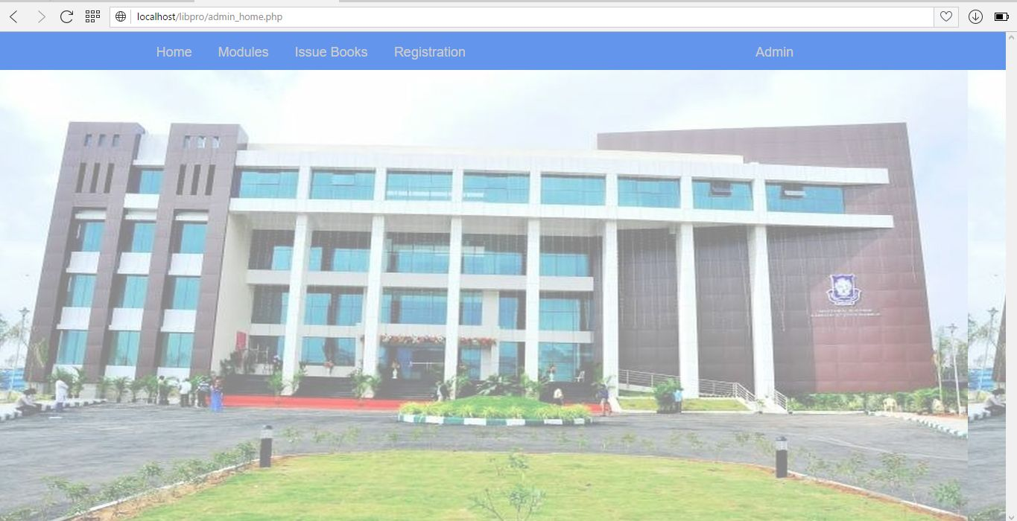

**ADD BOOK:**

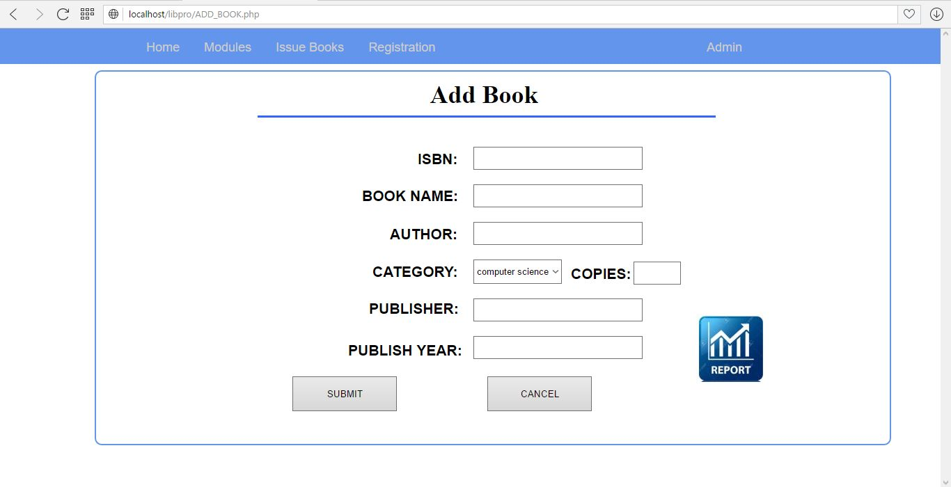

**MANAGE BOOK:**

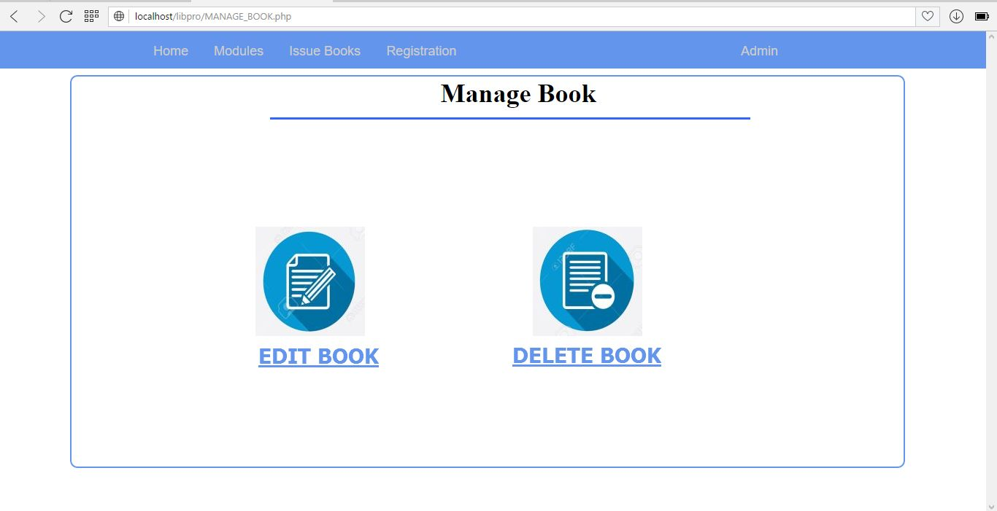

**EDIT BOOK:**

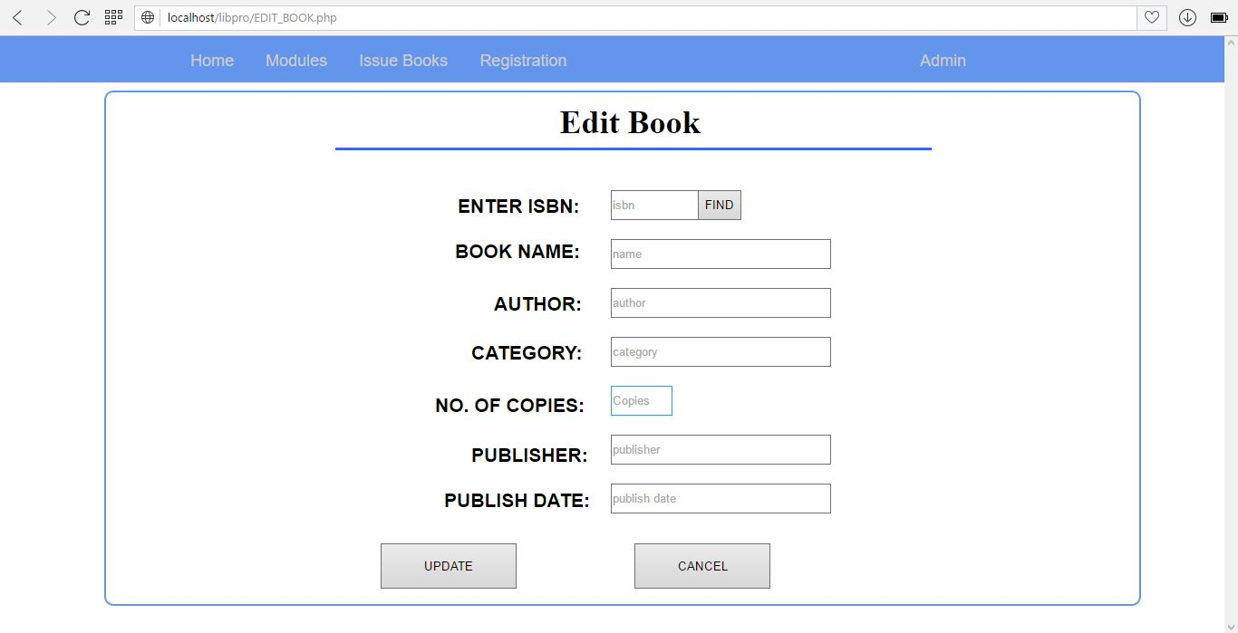

**DELETE BOOK:**

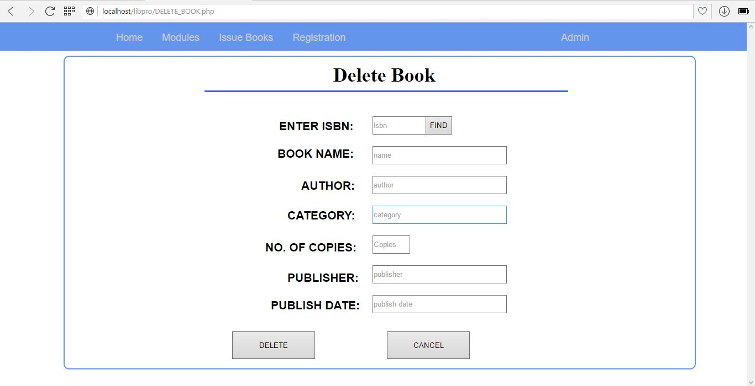

**BOOK ISSUE:**

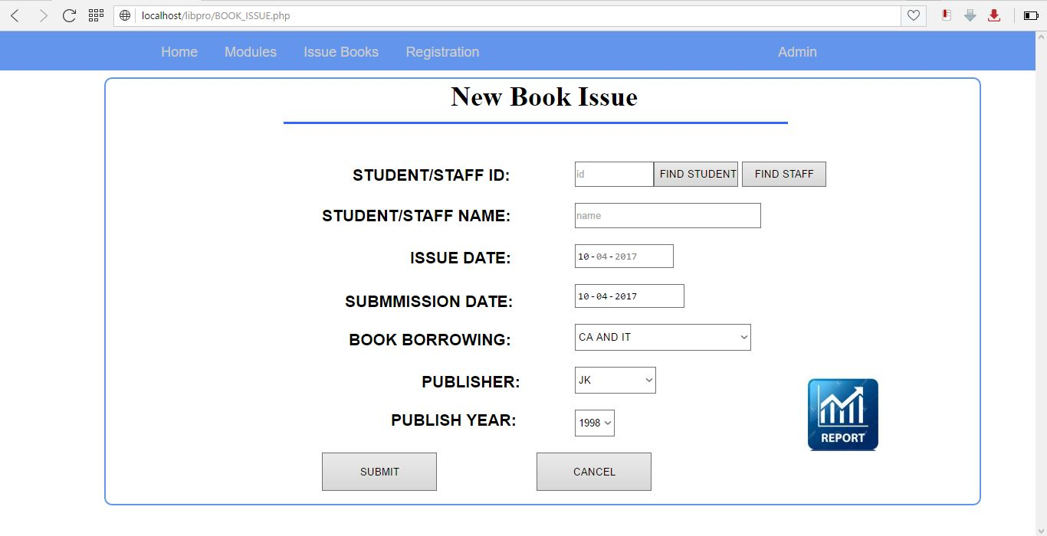

**BOOK RETURN:**

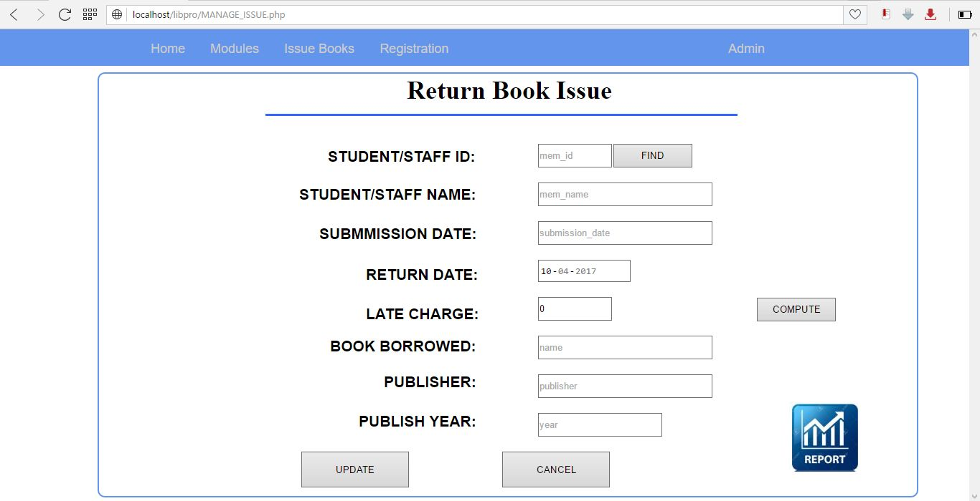

**STAFF REGISTRATION:**

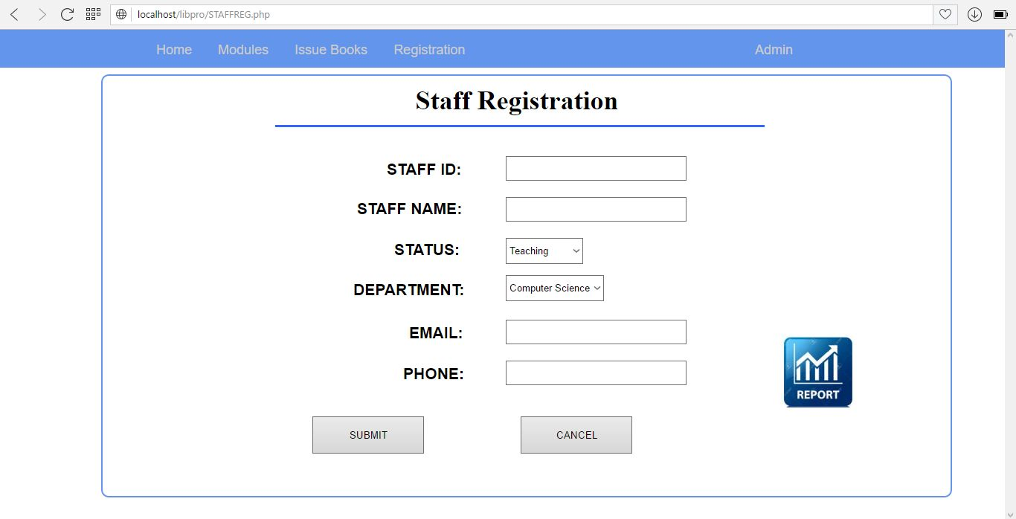

**STUDENT REGISTRATION:**

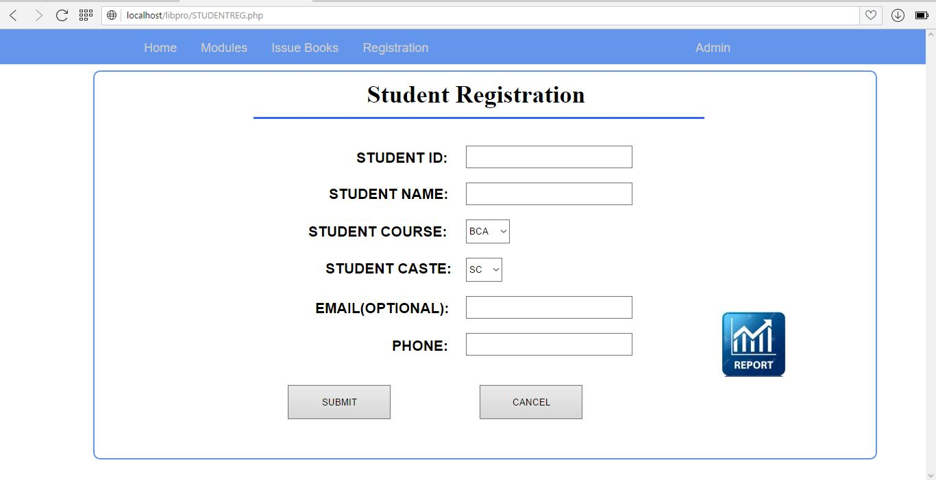

**MANAGE STUDENT/STAFF PROFILE:**

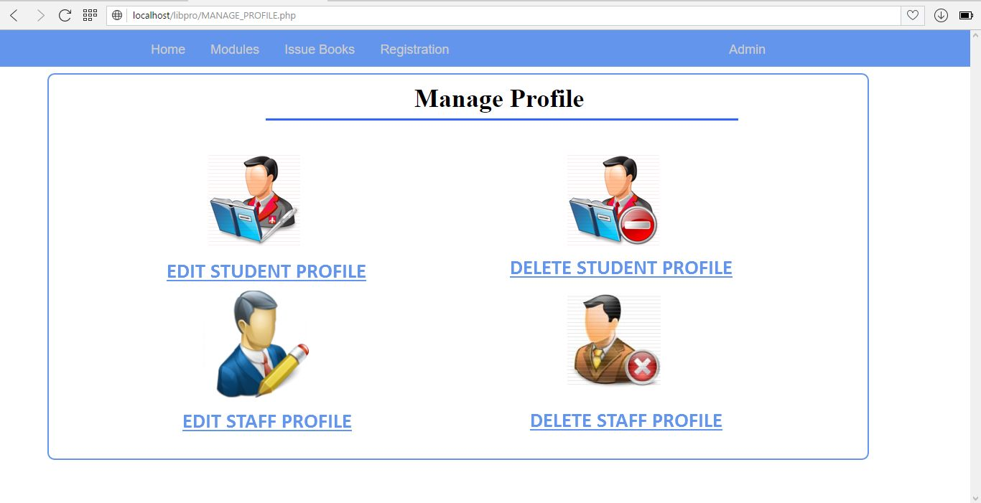

**EDIT STUDENT:**

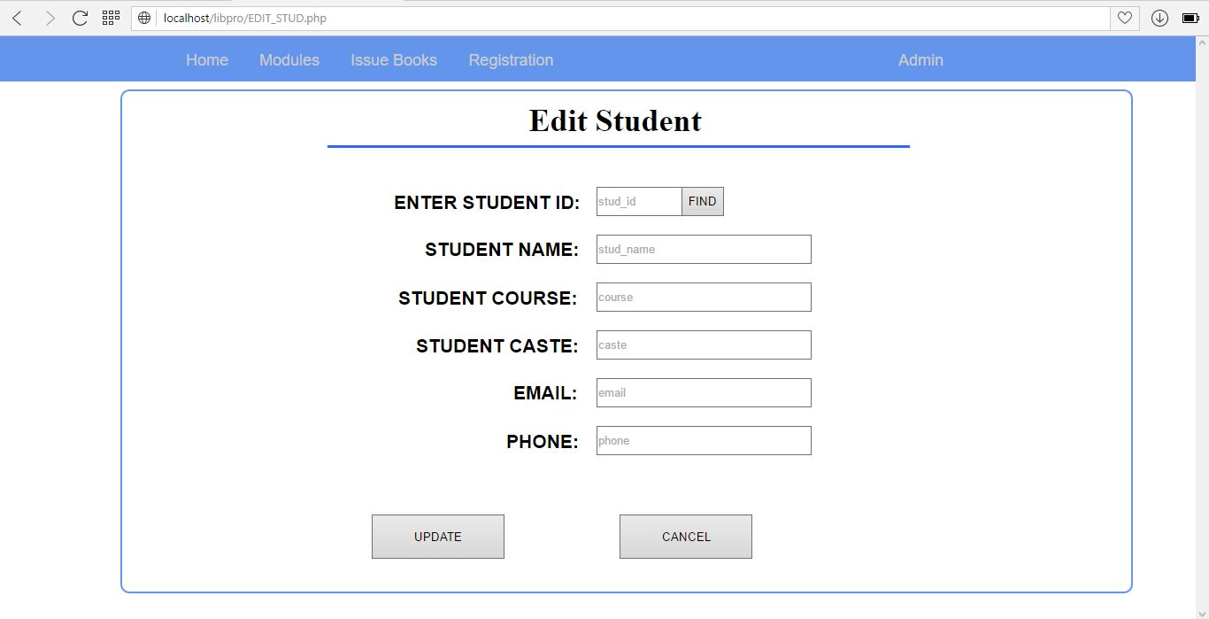

**DELETE STUDENT:**

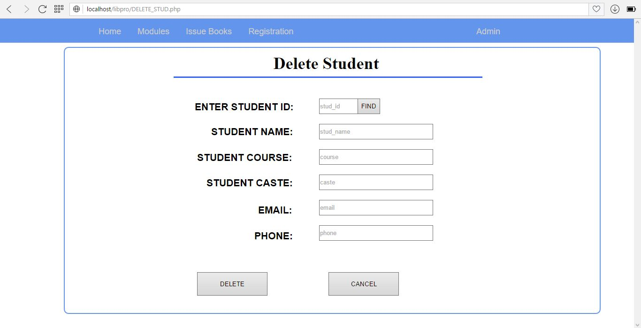

**EDIT STAFF:**

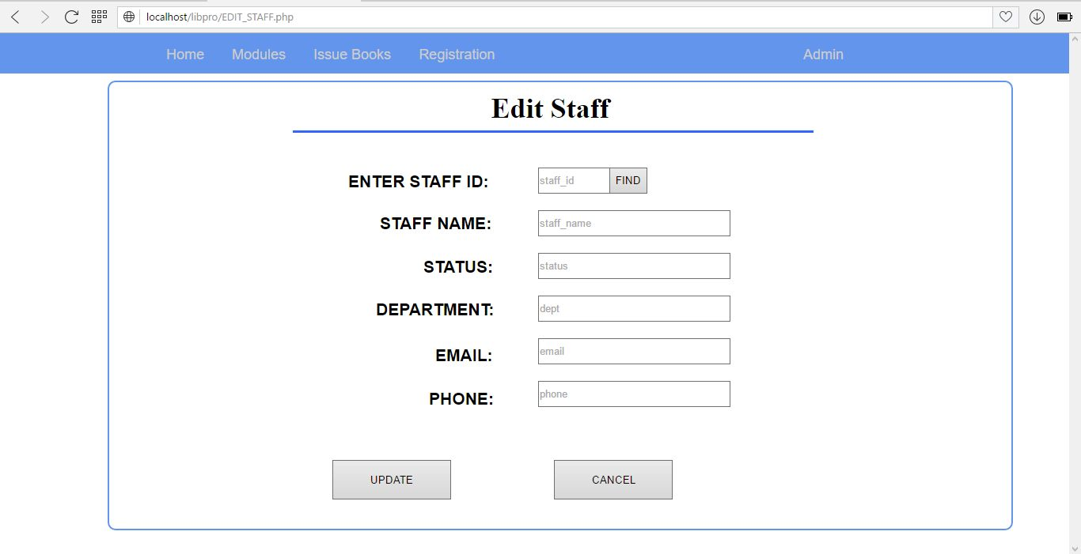

**DELETE STAFF:**

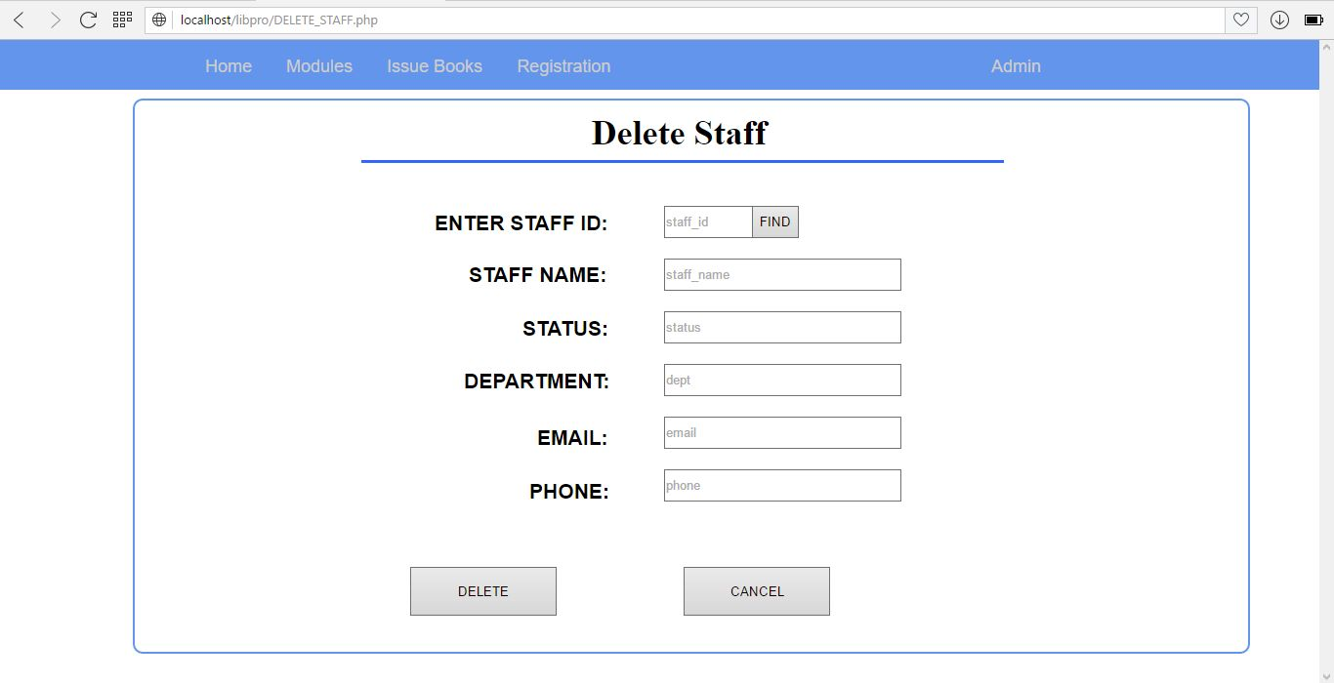

**USER HOME:**

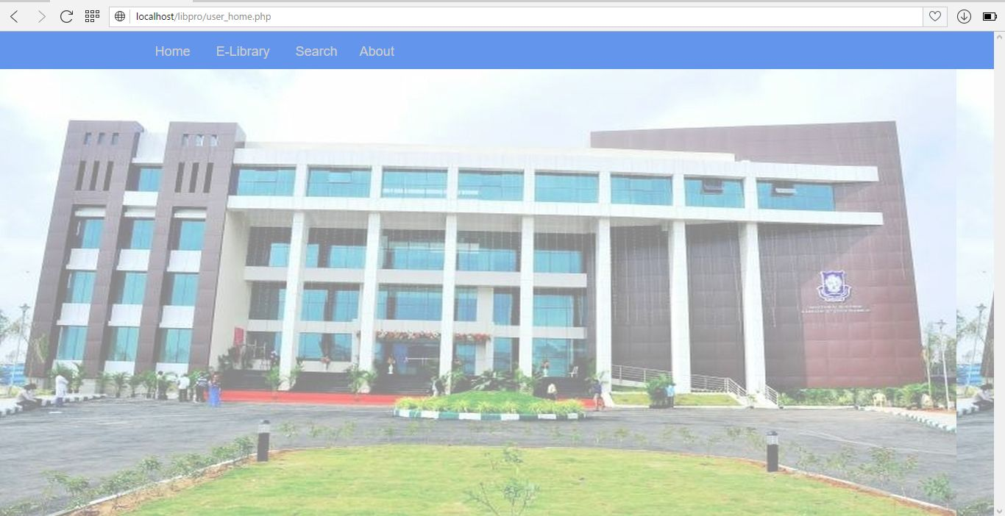

**E-LIBRARY(COMPUTER SCIENCE):**

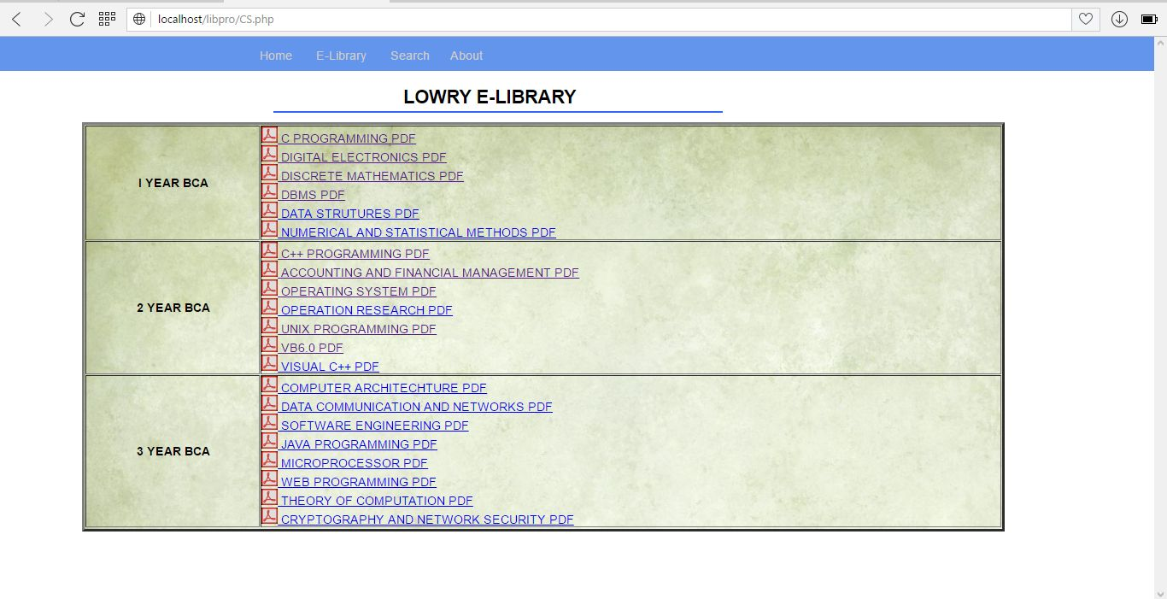

**E-LIBRARY(COMMERCE):**

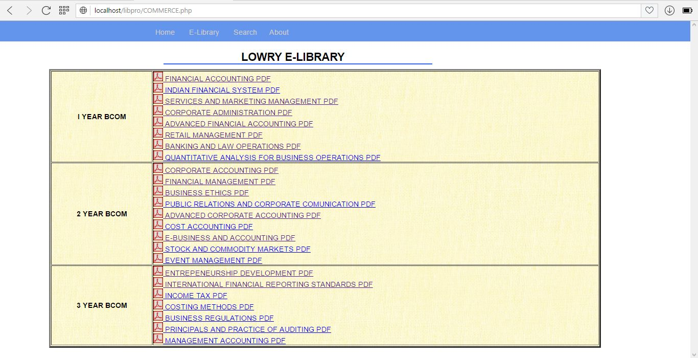

**E-LIBRARY(MANAGEMENT):**

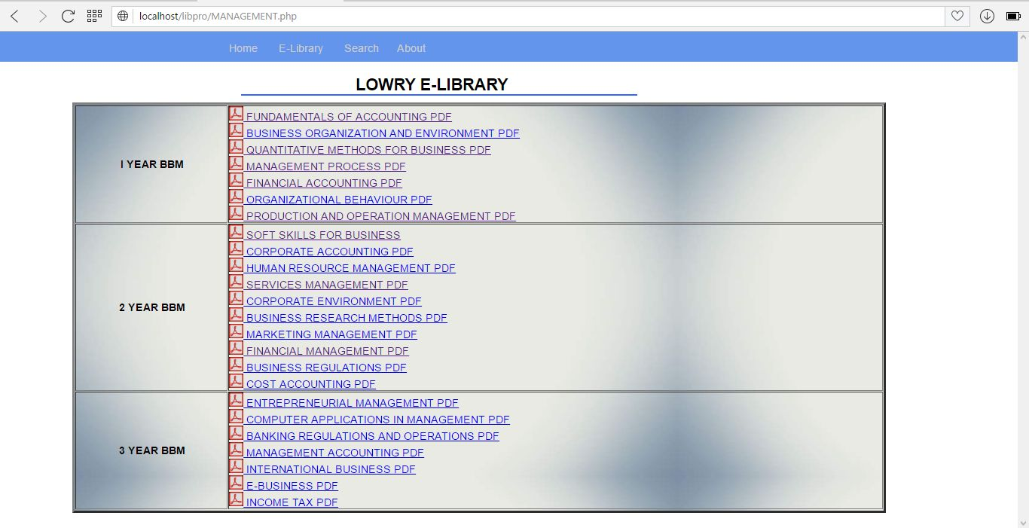

**USER SEARCH:**

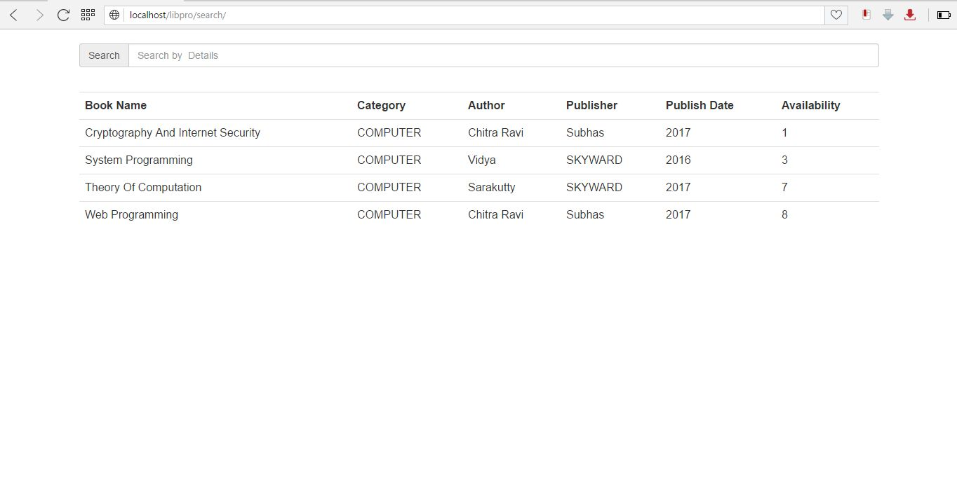

**Limitations:**

Each and every system has some limitations that can restrict them to work in a Particular environment.Though our system is provided high amount of accuracy and quick data generation,there is still some limitations that led us to in greater deficiency on that system.Some of the limitations that is observed during the process is:

* This system requires a knowledgable person to use the system.
* This system lacks interaction of members with the librarian.
* This system does not allow blocking of books online.
* This system does not manage the pricing of books.

**Enhancements:**

* In future our system can include good backup and restore facility.
* In future our system can include functions to block books online.
* In future you can add new modules like purchasing of old books.

**Reference Related to different websites:**

**1bestcsharp.blogspot.in**

**https://www.tutorialspoint.com**

**https://stackoverflow.com**

**https://www.w3schools.com**

**http://php.net**

**http://www.guru99.com**

[**http://www.javatpoint.com**](http://www.javatpoint.com)

[**https://www.thesoftwareguy.in**](https://www.thesoftwareguy.in)

**http://www.91weblessons.com**